Unit 6: Application of Probability
Name: _________________________
Period: _____

2018 – 2019 Geometry
Pebblebrook High School – Deuire

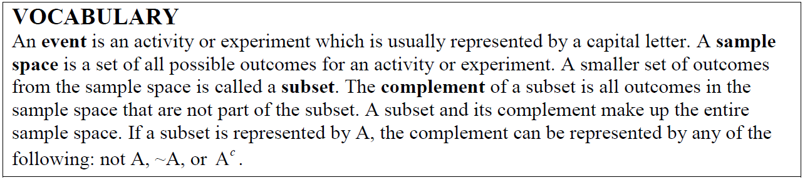

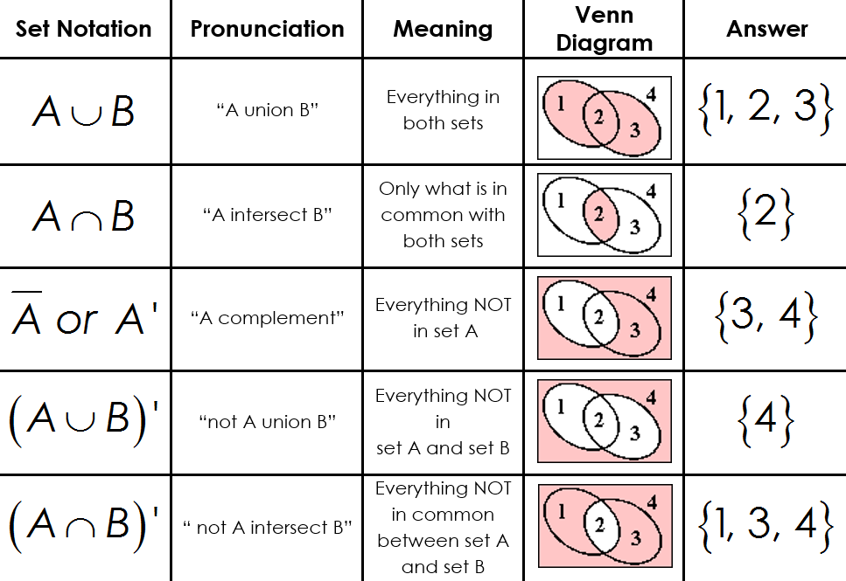

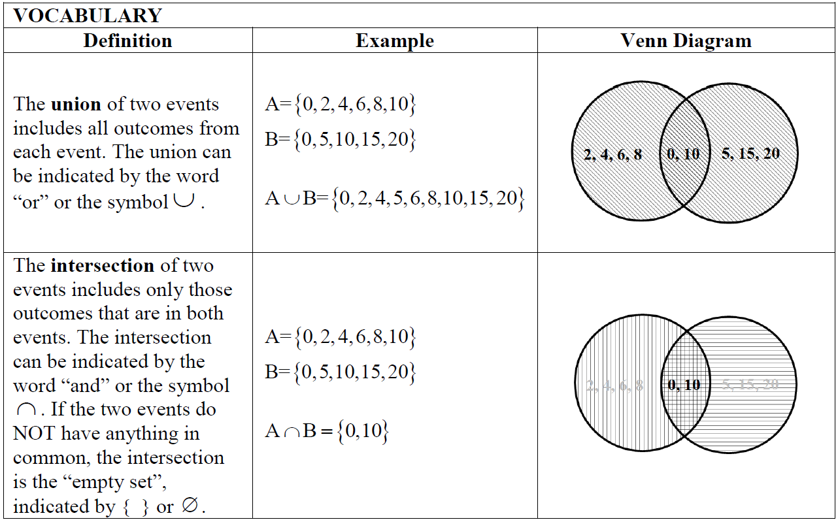

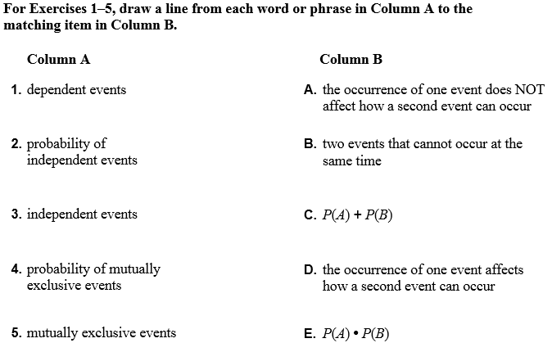

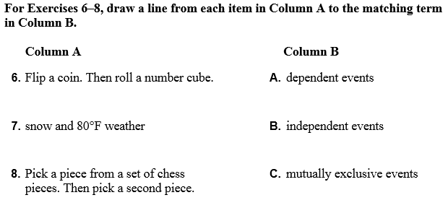

6-1 Theoretical vs. Experimental Probability and Venn Diagrams

__Probability_ is the chance or likelihood of an event occurring. There are 2 types of probability: __theoretical__ and experimental.
__Theoretical Probability__ is the probability of an event that is the ratio or the number of favorable outcomes to the total possible outcomes. __Sample space__ is the set of all possible outcomes.
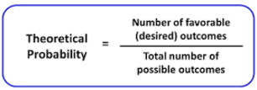

Example 1
List the sample space for rolling a six-sided die.
S = ___________________

Find the following probabilities.
2.
3.
1.
$P\left(2\right)=$ $P\left(3 or 6\right)=$ $P\left(odd\right)=$
6.
5.
4.
$P\left(not a 4\right)=$ $P\left(1, 2, 3, 4, 5, or 6\right)=$ $P\left(8\right)=$

Example 2
List the sample space for tossing two coins:

(Heads, Tails), (Heads, __________) (________, ________), (________, ________)

Find the following probabilities.
4.
1.
$P\left(2 heads\right)=$ $P\left(all tails\right)=$
5.
3.
2.
$P\left(1 head and 1 tail\right)=$ $P\left(head, then tail\right)=$
6.
$P\left(no tails\right)=$ $P\left(2 tails\right)=$

__Experimental Probability__ is the ratio of the number of times the event occurs to the total number of trials.
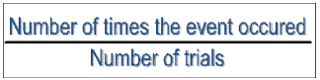

Do you think that theoretical and experimental probabilities will be the same for a certain event occurring?
Yes. The more trials you do, the closer your experimental probability will be to your theoretical probability.

Example 3
Roll a six-sided die and record the number on the die. Repeat this 9 more times.
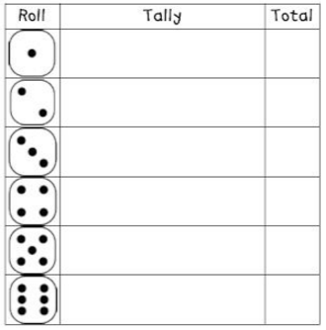
Based on your data, find the following experimental probabilities:
2.
1.
$$P\left(2\right)=$$
$P\left(3 or 6\right)=$
3.
$P\left(odd\right)=$
4.
$P\left(not a 4\right)=$
5.
If we roll the die 80 times, how many times can we expect to roll a 5?

Sample space: list of all possible outcomes
List the sample space, S, for each of the following:
Tossing a Coin: _____________________________________________________________________

Rolling a six-sided die: ____________________________________________________________

Drawing a marble from a bag that contains two red, three blue, and one white marble: _____________________________________________________________________________

Intersection of two sets$(A∩B)$: the overlapping of elements from two sets; “THE COMMON ELEMENTS”_____

Union of two sets ($A∪B)$: Combining the elements to create one set

Example 4
Given the following sets, find $(A∩B)$ and ($A∪B)$.

Given the following sets, find $(P∩Q)$ and ($P∪Q)$.
=_________________________ =______________________________

Venn diagram:
A visual representation of the relationship between two or more sets
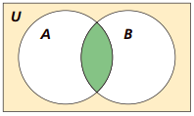

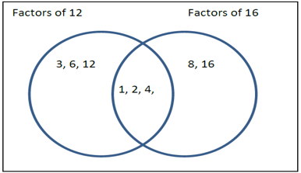
Example 5
Use the Venn diagram to answer the following questions:
1.
What are the elements of set A?
2.
What are the elements of set B?
3.
Why are 1, 2, and 4 in both sets?

What is $(A∩B)$?
4.
5.
What is ($A∪B)$?

Example 6
In a class of 60 students, 21 signed up for chorus, 29 signed up for band, and 5 take both. 15 students in the class are not enrolled in either band or chorus.
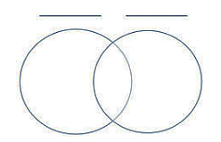
Record in Venn Diagram, let students in chorus be set A and students in band be set B.
1.

3.
2.
What is ($A∪B)$? What is $(A∩B)$?

Example 7
1.
Organize the data
Factors of 64:
___________________________________
Factors of 24:
__________________________________

Answer the questions about the Venn diagram below.
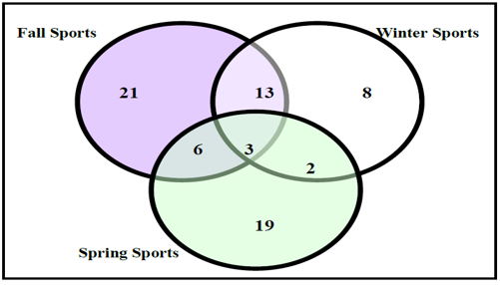

2.
How many students play sports year around?
How many students play sports in the spring and fall?
4.
3.
How many students play sports in the winter and fall?
5.
How many stududents play sports in the winter and spring?
6.
How many students play only one sport?
7.
How many students play at least two sports?

Complement of a set:
All outcomes in the sample space that are not part of the subset

Example 8
Find each set.
1.
What is $\overline{A}$?
2.
What is $\overline{B}$?

What is $\overline{A∪B}$?
3.
4.
What is $\sim (A∩B)$?

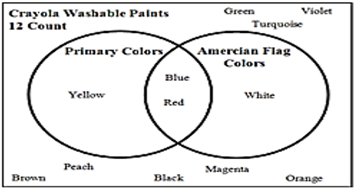
Example 9
1.
The sample space is:
S = _____________________________________

The subset of primary colors:
P = _____________________________________

The subset of American Flag:
A = ____________________________________
4.
3.
2.
$P∪A=$ $P∩A=$ $\sim (P∪A)=$
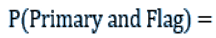
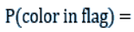
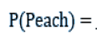
6.
7.
5.
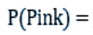
8.

6 – 2 Mutually Inclusive & Mutually Exclusive Events
Suppose you are rolling a six-sided die. What is the probability that you roll an odd number or you roll a 2? ________________________________________________
Can these both occur at the same time? Why or why not? ________________________________________________

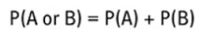

Mutually Exclusive Events: Two events that cannot occur at the same time_____

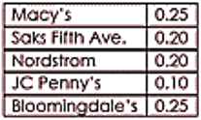
Example 1
1.

Find the probability that a girl’s favorite department store is Macy’s or Nordstrom.

Find the probability that a girl’s favorite store is not JC Penny’s.
2.

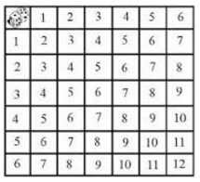
3.
When rolling two dice, what is the probability that you sum will be 4 or 5?

What is the probability of picking a queen or an ace from a deck of cards?
4.

Example 2
Jack is a student in Bluenose High School. He noticed that a lot of the students in his math class were also in his chemistry class. In fact, of the 60 students in his grade, 28 students were in his math class, 32 students were in his chemistry class, and 15 students were in both math class and his chemistry class. He decided to calculate what the probability was of selecting a student at random who was either in his math class or his chemistry class, but not both. Draw a Venn diagram and help Jack with his calculation.

Mutually Inclusive/Overlapping Events: The probability that either of the events occur is the sum of the probabilities of the events minus the probability that both events occur

Example 3
1.
A card is chosen at random from a standard deck of cards. What is the probability that the card chosen is a heart or a face card? Are these events mutually inclusive?

What is the probability of choosing a number from 1 to 10 that is greater than 5 or even?
2.

3.
A bag contains 26 tiles with a letter on each, one tile for each letter of the alphabet. What is the probability of reaching into the bag and randomly choosing a tile with one of the letters in the word ENGLISH on it or randomly choosing a tile with a vowel on it?

Example 4
Brenda did a survey of the students in her classes about whether they liked to get a candy bar of a new math pencil as their reward for positive behavior. She asked all 71 students she taught, and 32 said they would like a candy bar, 25 said they wanted a new pencil, and 4 said they wanted both. If Brenda were to select a student at random from her classes, what is the probability that the student chosen would want:
1. a candy bar or a pencil?

2. neither a candy bar nor a pencil?

6 – 3 Independent & Dependent Events
Independent Events: The occurrence of one event does not affect how a second event can occur

Dependent Events: The occurrence of one event affects how a second event can occur

Suppose a die is rolled and then a coin is tossed, explain why these events are independent: _coin toss does not depend on the die roll

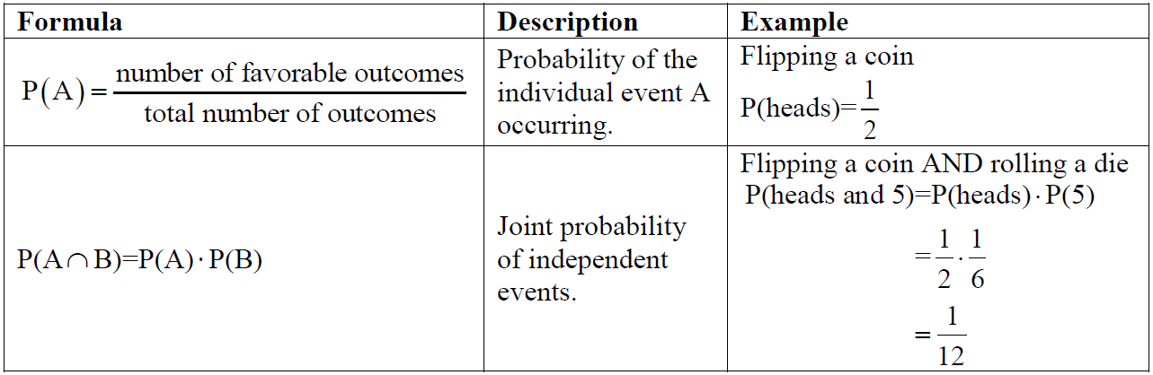

Example 1
Tell whether the events are independent or dependent. Explain.
2.
You flip a coin twice.
First Flip: Heads.
Second Flip: Heads.
You roll a number cube twice.
First Roll: You roll a 4.
Second Roll: You roll an
even number
1.

You randomly draw a marble from a bag containing 2 red marbles and 5 green marbles.
4.
You put the marble back and then draw a second marble.
First Draw: Green
Second Draw: Red
3.
You keep the marble and then draw a second marble.
First Draw: Green
Second Draw: Red

Example 2
1.
2 cards are chosen from a deck of cards. The first is replaced before the second card is drawn. What is the probability that they both will be clubs?

2.
Suppose you have a bag containing 2 black marbles and 3 red marbles. You reach into the bag, select a marble and replace it in the bag. What is the probability of picking a red marble both times?

Example 3
1.
Suppose a card is chosen at random from a deck, the card is NOT replaced, and then a second card is chosen from the same deck. What is probability that both will be 7s?

2.
A box contains 5 red marbles and 5 purple marbles. What is the probabilty of drawing 2 purple marbles and 1 red marble without replacement?

Example 4 - Independent
- Determine the following probabilities if each of the following are independent.

GIVEN: P(A) = 0.8 P(B) = 0.25 P(C) = 0.6

- P( A and C) =
Decimal:

- P(A and B and C) =
Decimal:

Example 5 - Independent
- P(Rolling a 4 on a standard die and B) =
Decimal:

- If your chances of losing the shell game if you randomly pick is 2 in 3. What are the chances that you would lose 5 games in a row?
Decimal:

- If the Atlanta Hawks free throw percentage is 82%, what is the probability that a player for the Hawks will make 2 free shots in a row?
Decimal:

Example 6 - Dependent
In a classroom there are 7 male students and 11 female students that are taking a test. If each student is equally likely to turn in their test at any given time at the end of class, what is the probability that the first 3 students to turn in their test are female students?
6 – 4 Conditional Events & Frequency Tables
Conditional Probability: The chance of a second event occurring if the first event has already occurred_____________________

Examples of Conditional Probability

Scenario 1: ___IF EVENT A, THEN EVENT B___

Scenario 2: ___EVENT B, GIVEN EVENT A____

The conditional probability of A given B is expressed as:
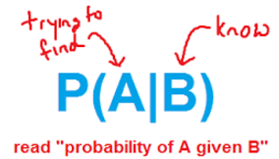
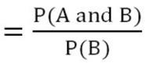

Example 1 – Simple Conditional
You are playing a game of cards where the winner is determined by drawing two cards of the same suit. What is the probability of drawing clubs on the second draw if the first card drawn is a club?

Example 2 – Simple Conditional
A bag contains 6 blue marbles and 2 brown marbles. One marble is randomly drawn and discarded. Then a second marble is drawn. Find the probability that the second marble is brown given that the first marble drawn was blue.

$$P\left(A|B\right)=\frac{intersection}{last total}$$

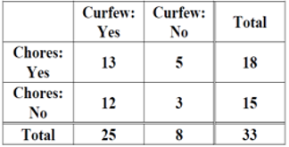
Example 3 – Complex Conditional
P(has chores) = ________________
1.

P(no curfew) = _______________
27.

P(curfew and chores) = _______________
3.

P(chores ∩ no curfew) = ______________
4.
5.
P(has curfew) = ______________

Example 4 – Complex Conditional
Suppose we survey all the students at school and ask them how they get to school and also what grade they are in. The chart below gives the results. Complete the two-way frequency table:
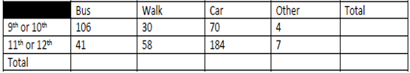

Suppose we randomly select one student.
1.
What is the probability that the student walked to school?
2.
P(9th or 10th grader) =
3.
P(rode the bus OR 11th or 12th grader) =
4.
What is the probability that a student is in 11th or 12th grade given that they rode in a car to school?

5.
What is P(Walk|9th or 10th grade) =

Example 5 – Complex Conditional
The manager of an ice cream shop is curious as to which customers are buying certain flavors of ice cream. He decides to track whether the customer is an adult or a child and whether they order vanilla or chocolate. He finds that of his 224 customers in one week that 146 ordered chocolate. He also finds that 52 of his 93 adult customers ordered vanilla. Build a two way frequency table that tracks the type of customer and type of ice cream.
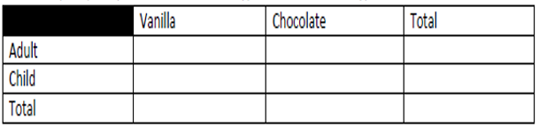

P(vanilla|adult) = _______________

P(child|chocolate) = ______________

