Unit 4: Circles and Volume
GSE Geometry

Part B: 4.5 – 4.8

Name: ________________________________________
Period: _______
Pebblebrook High School
Mrs. Deuire

4 – 5 Congruent Chords and Arcs
A circle is the collection of points that are equidistant from a given point. The distance from the center to a point is the length of the radius of the circle.
A chord is a line segment that has both endpoints on a circle. Two chords within the same circle can have different lengths. A diameter is a chord that passes through the center of a circle. Diameters are the longest possible chords in a circle. The length of the diameter of a circle is twice the length of its radius.
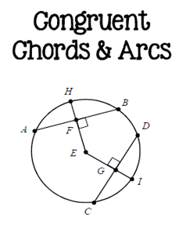 | - Two shords are congruent if and only if:  - Their corresponding arcs are $≅$  AB = CD $↔$ m$\hat{AB}$ = m$\hat{CD}$  - Their corresponding radii parts are $≅$  AB = CD $↔$ EF = EG  - If a diameter or radius is perpendicular to a chord, then it bisects the chord and its arc.  EH $⊥$ AB $→$ AF = FB and m$\hat{AH}$ = m$\hat{HB}$

Example 1
Find the indicated value.
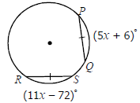
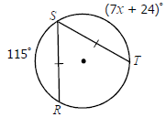
2.
1.

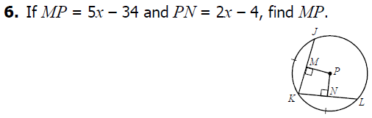
3.

Example 2
Find the indicated value.
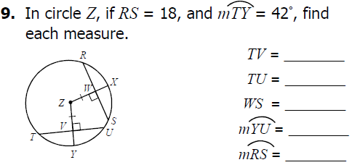
1.

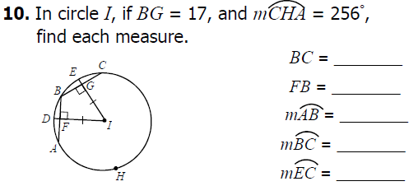
2.

Example 3
Find x (round to the nearest hundredth).
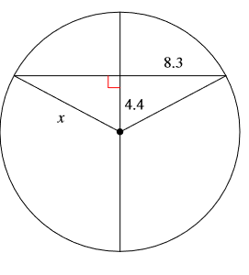

Example 4
Find x (round to the nearest hundredth).
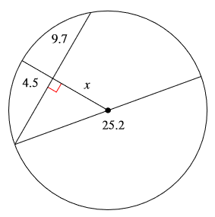

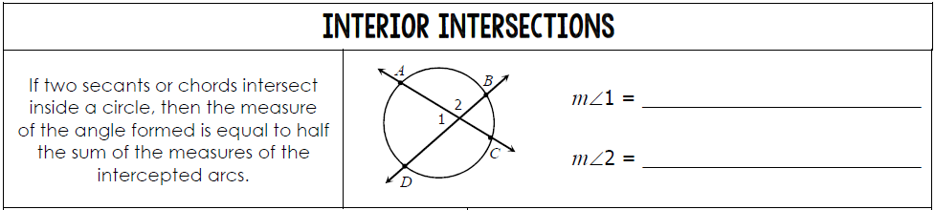
4 – 6 More Chords, Secants, and Tangents
$\frac{1}{2}(m\hat{AB}+m\hat{CD}$)
$\frac{1}{2}(m\hat{AD}+m\hat{BC}$)
Example 1
1.
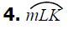
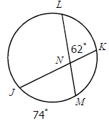
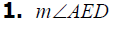
2.
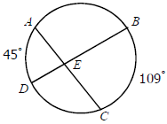

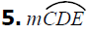
4.
3.
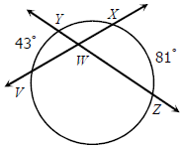
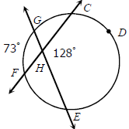

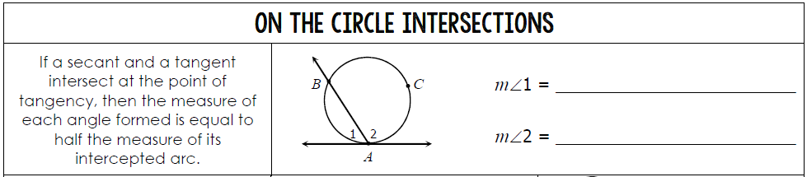
$\frac{1}{2}(m\hat{ACB}$)
$\frac{1}{2}(m\hat{AB}$)
Example 2
Find the indicated value.
1.
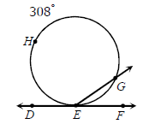
2.
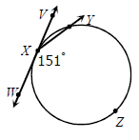

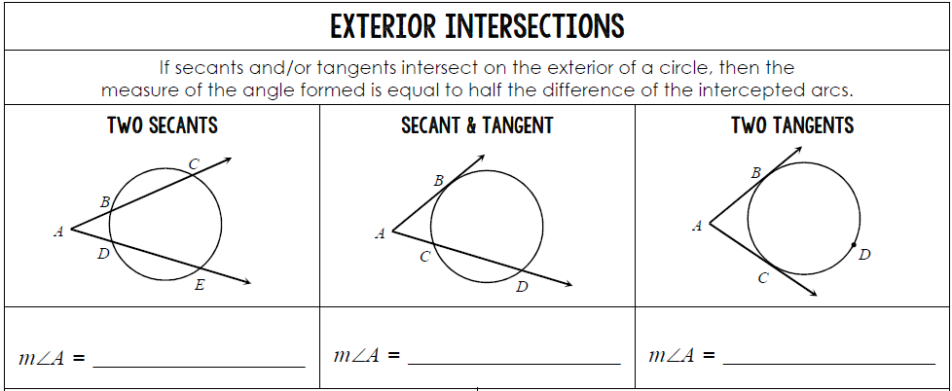

$\frac{1}{2}(m\hat{BDC}-m\hat{BC}$)
$\frac{1}{2}(m\hat{CE}-m\hat{BD}$)
$\frac{1}{2}(m\hat{BD}-m\hat{BC}$)

Example 3
Find the indicated value.
2.
1.
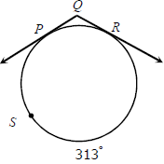
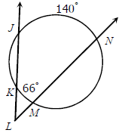
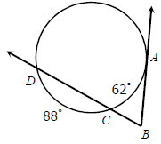
3.

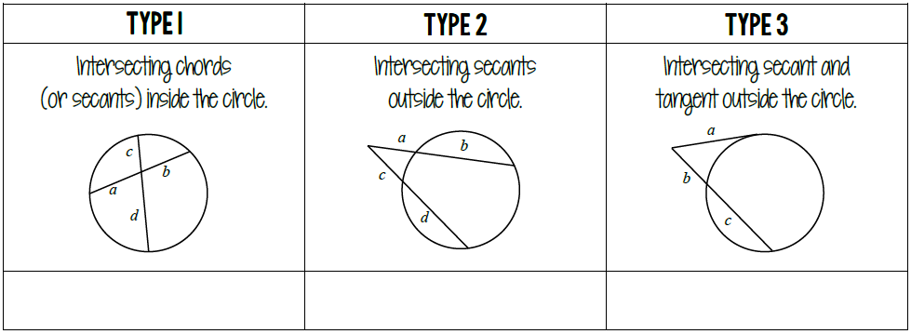
Segments

$$a^{2}=b(b+c)$$
$$a(a∙b)=c(c∙d)$$
$$a∙b=c∙d$$

Example 4
Find each value or measure. Assume segments that appear to be tangent are tangent.
3.
2.
1.
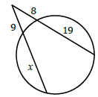
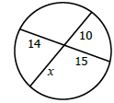
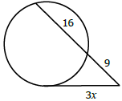

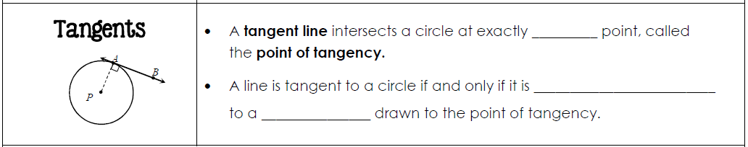
one
perpendicular

radius

Example 5
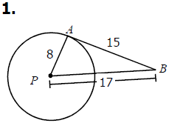
Determine if $\overline{AB}$ is tangent to circle P.
1.

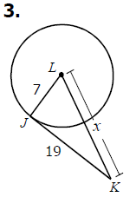
If $\overline{JK}$ is tangent to circle L, find x.
2.

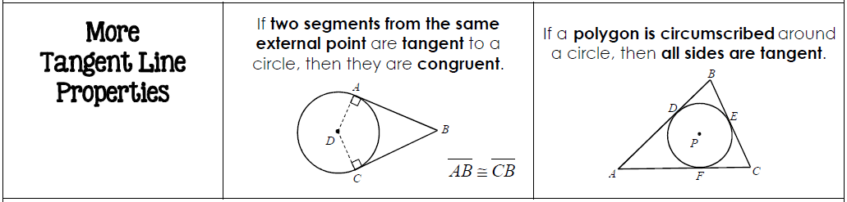

Example 6
Find the indicated value.
1.
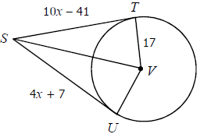

2.
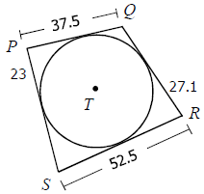

4 – 7 Volume of Prisms, Pyramids, and Spheres
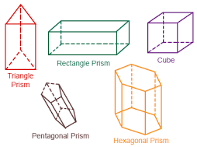
Volume is a measure of how much space a 3-dimensional figure occupies. The basic unit of volume is a cubic unit.
In calculating the volume, it is important to know that if 2 solids are congruent, then their volumes are congruent also.
A right rectangular prism is a prism with rectangular bases and the angle between each base and its rectangular lateral sides is also a right angle. You can calculate the volume of any right rectangular prism by multiplying the length of the solid, the width , and its height .
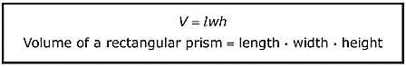

Example 1
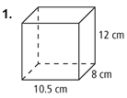
Find the volume of each rectangular prism.
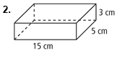

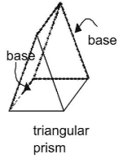
Looking at the volume of right prism with the same height and different bases.
To find the volume of a right prism, you multiply the area of its base by the height of the prism.

VOLUME OF TRIANGULAR PRISM:
$V=\frac{lwh}{2}$

Example 2
Find the volume of each triangular prism.
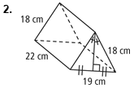
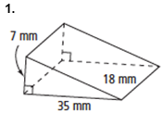

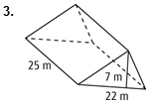

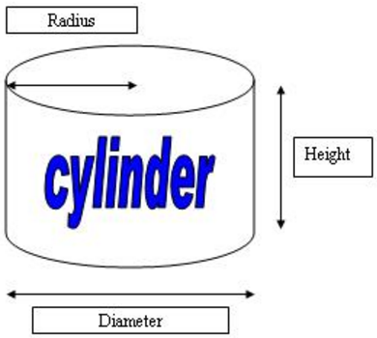
In the case of cylinders, you can think of volume as the capacity, or the amount of liquid or substance, it can hold.
To calculate the volume of a cylinder, start by calculating the area of the circular base, then multiply by the height.
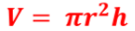

Example 3
Find the volume of each cylinder in terms of π and to the nearest tenth.
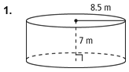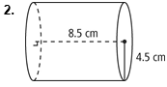

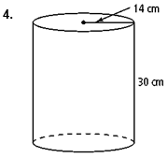
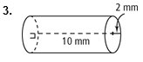

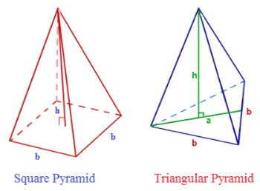
Pyramids are unusual because they are so much smaller at the top than they are at their base.
The important thing to remember is that measuring volume involves filling up a solid figure.
A pyramid has exactly one-third the volume of a cube.
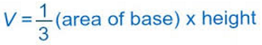

Example 4
Find the volume of each pyramid. Round to the nearest whole number.
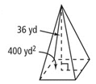
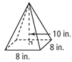
2.
1.

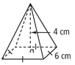
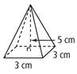
4.
3.

Sometimes the height of a triangular face in a square pyramid is not given.
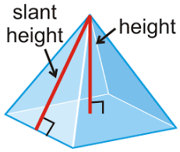
When the slant height and the lengths of the sides are given, you must use what you know about right triangles to find the missing value which is the Pythagorean Theorem, then calculate the volume as usual.

Example 5
Find the volume of each pyramid, given its slant height. Round to the nearest tenth.
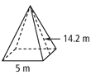
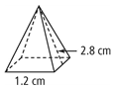
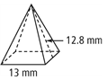
3.
2.
1.

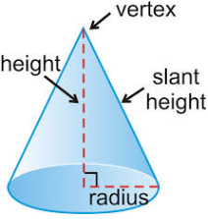
Cones are unusual because they are so much smaller at the top than they are at their base.
A cone has exactly one-third the volume of a cylinder.
Since the base of a cone is a circle, the formula for find the volume is below.
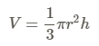

Volume of Cones:

Example 6
Find the volume of each cone in terms of π.
1.
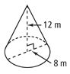
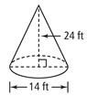
2.

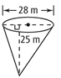
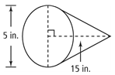
4.
3.

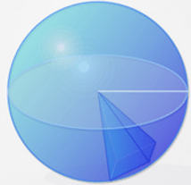
To find the volume of spheres, you can use pyramids.
Imagine a pyramid with its base on the surface of the sphere and its point as the center of the sphere.
The radius of the sphere would be the height of the pyramid.
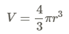

Volume of Sphere:

Example 7
Find the volume of each sphere. Give each answer in terms of π and rounded to the nearest cubic unit.
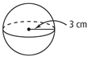
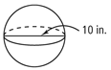
2.
1.

3.
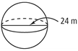
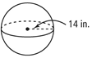
4.

A composite solid is a solid that is composed, or made up of two or more solids the solids that it is made up of are generally prisms, pyramids cones, cylinders, and spheres.

Example 8
1.
Find the volume of the solid.
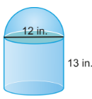

2.
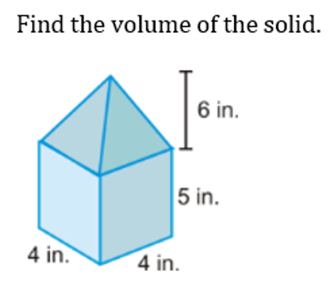

Tennis balls with a 3 inch diameter are sold in cans of three. The can is a cylinder. Round your answer to the nearest hundredth. What is the volume of one tennis ball? What is the volume of the cylinder? What is the volume of the space NOT occupied by the tennis balls?
3.

4 – 8 3-Dimensional Figures
A polyhedron is a solid with flat surfaces that are polygons.
Some terms associated with three-dimensional figures are edge, face, vertex, and diagonal.
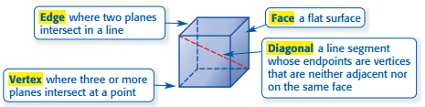

The intersection of a solid and a plane is called a cross section of the solid.
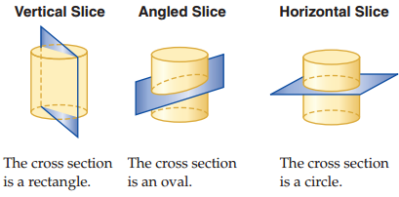

Every cross section of a polyhedron is a polygon.
Figures that are not polygons such as cylinders and cones, have some cross sections that are circles or ellipses.
For all prisms and cylinders, all cross sections made parallel to the bases are congruent to the bases.
For pyramids and cones, all cross sections made parallel to the base are similar to the base but different in size.
Example 1
Describe the shape resulting from each cross section.
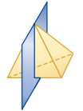
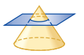
2.
1.

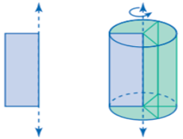
You can produce a three-dimensional solid by rotating a two-dimensional figure around a line called an axis.

Example 2
Determine the 3-D solid that would be formed by rotating the cross section about the line m.
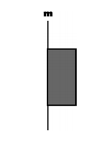
1.

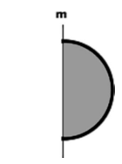
2.

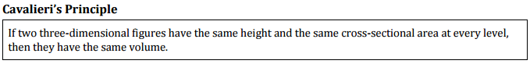

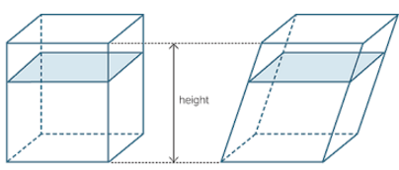

Example 3
Cylinder A and Cylinder B are shown below. What is the volume of each cylinder?
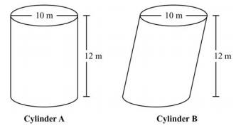

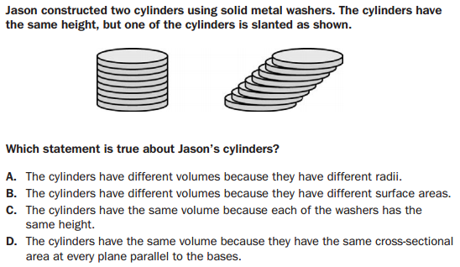
Example 4

