Unit 4: Circles and Volume
GSE Geometry
Name: __________________
Period: _____

2018 – 2019 Geometry
Pebblebrook High School
Mrs. Deuire

Part A: 4.1 – 4.4
4 – 1 Similar Circles and Proportions

All circles are similar if there exists a sequence of transformations that maps circle A onto circle B.

In the diagram to the right, Circle A can be mapped onto circle B by first rotating circle A onto circle B, and then dilating circle A, centered at A, by a scale factor of $\frac{5}{3}$ .
Since there exists a sequence of transformations that maps circle A onto circle B, circle A is similar to circle B.
Performing a translation and dilation can transform a circle into any other circle. In other words, all circles are similar.

Example 1

Find the circumference of circle 1 and circle 2.
10
5

Write the ratio of circumference to the radius.

Determine whether the two circles are similar.

The length of the arc intercepted by a central angle is proportional to the radius.

The diagram at the right shows two circles with the same center called concentric circles. It has already been shown that concentric circles are similar under a dilation transformation.
The scale factor is found by the following:
$$\frac{smaller circle}{larger circle}= \frac{r_{1}}{r_{2}}$$

The same dilation that mapped the smaller circle onto the larger circle will also map the sector of the smaller circle with an arc length of s₁ onto the slice sector of the larger circle with an arc length of s₂. When the radius gets dilated by a scale factor, the arc length is also dilated by that same scale factor.
An equivalent proportion can be written as $\frac{s_{1}}{r_{1}}=\frac{s_{2}}{r_{2}}$ . This proportion shows that the ratio of the arc length intercepted by a central angle to the radius of the circle will always yield the same (constant) ratio.
Example 2:
In the concentric circles below, $\hat{AB}$ = 50 and $\hat{CD}$ = 25
The length of PC is 5.
Find x.

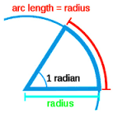
4 - 2 Circumference and Arc Length of a Circle
Angles can be measured in units of either __degrees__ or __radians__. A complete revolution is defined as __360⁰__ or __$2π$__radians.
It is easy to use the fact that 360˚ = 2π radians to convert between the two measures.
When converting radians to degrees or degrees to radians, use the proportion

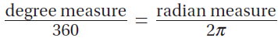

Example 1
Find the measure of each angle in radians.

Find the measure of each angle in degrees.

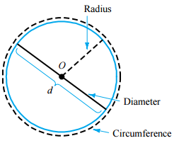
The distance around the outside of a circle is closely related to the concept of __perimeter__. We call the perimeter of a circle the __circumference__.
The distance across the circle through its center is the _diameter_. The _radius_ is the distance from the center to a point on the circle. The diameter is always _double_ the radius.
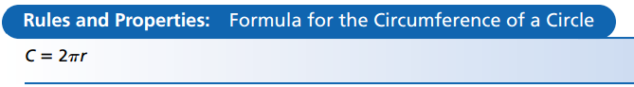
It was discovered long ago that the _ratio_ of the circumference of a circle to its diameter always stay the same. The ratio has a special name, __$π$__. Pi is approximately __$\frac{22}{7}$__ or __3.14__.
Example 2
Find the circumference of each circle.
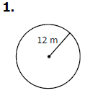
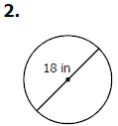

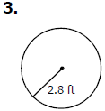

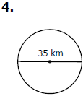

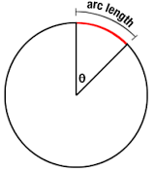
One way to measure arcs is in __degrees__. This is called the __angle measure__ or degree measure. Arcs can also be measured in length, as a portion of the __circumference__.
__Arc length__ is the length of an arc or portion of a circumference. The arc length is directly related to the degree arc measure.
Central Angle in Degrees | Central Angles in Radians
The formula for the arc measure is:  $$arc length=2πr\left(\frac{C}{360}\right)$$  Where:  C is the central angle of the arc in degrees  R is the radius of the arc  Π is Pi, approximately 3.14 | If the central angle is in radians, the formula is simpler  $$arc length=RC$$  Where:  C is the central angle of the arc in radians  R is the radius of the arc

Example 3
Find the arc length.
1.
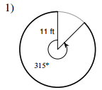

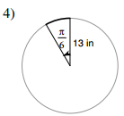
2.

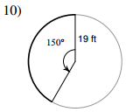
3.

4.
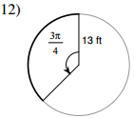

Example 4
Find the missing variable. Round to nearest hundredth if necessary.

- Arc Length = 66 2. Arc Length = 135
Central angle = $\frac{π}{2}$ Central Angle = 55$°$
Radius = Radius =

3. Arc Length = 300$π$ 4. Arc Length = 28
Central Angle = (in radians) Central Angle = (in degrees)
Radius = 6$π$ Radius = 7

4 – 3 Area and Area of a Sector
The number pi (π), which is used to find the circumference, is also used in finding the __area__ of a circle.

To find the area of a circle, all you need to know is its __radius__. We will leave our answers in terms of π, unless otherwise specified.
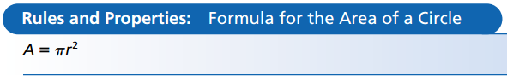

Example 1
Find the area.
1.
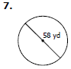
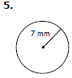
2.

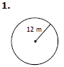
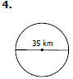
4.
3.

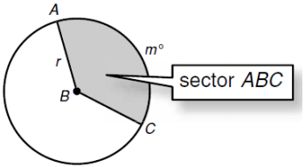
An __area of a sector__ is a region bounded by two radii of the circle and their intercepted arc.
In degrees, to find the area of the sector you will multiply the __area__ of the circle to the __angle ratio__ of the circle.

Central Angle in Degrees | Central Angles in Radians
The formula for the area of a sector is:  $$area of sector=\frac{θπr^{2}}{360}$$  Where:  $θ$ is the central angle of the arc in degrees  R is the radius of the arc  Π is Pi, approximately 3.14 | If the central angle is in radians, the formula is simpler  $$area of sector=\frac{1}{2}r^{2}θ$$  Where:  $θ$ is the central angle of the arc in radians  R is the radius of the arc

Example 2
Find the area of each sector.
1.
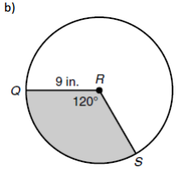
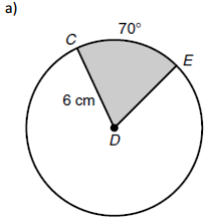
2.

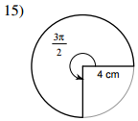
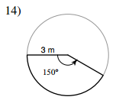
4.
3.

Example 3
Find the missing variable.

- Area of Sector = 72 2. Area of Sector = 125
Radius = 4 Radius =
Central Angle = (in degrees) Central Angle = 10$°$

Area of a Segment of a Circle
The segment of a circle is the region bounded by a chord and the arc subtended by the chord. The segment is the small partially curved figure left when the triangular portion of the sector is removed.
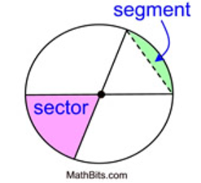
To find the area of the segment:
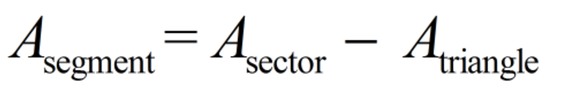

Example 4: Find the area of a segment of a circle with a central angle of 120 degrees and a radius of 8 cm. Express answer to the nearest integer.
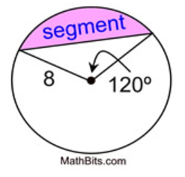
Step 1: Find the area of the sector
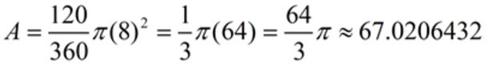

Step 2: Draw the line that represents the height (altitude) of the triangle.
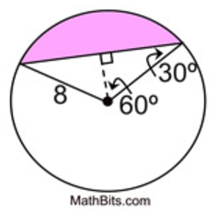
y
x

Step 3: Use the appropriate Trig ratio to find the missing sides
x = height of the triangle y = base of the triangle
Sin 60°= $\frac{y}{8}$ Cos 60°= $\frac{x}{8}$
8 ·sin 60 = y 8 ·cos 60 = x
6.93 = y 4 = x
Step 4: Find the area of the triangle.
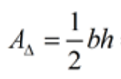
= $2 (\frac{1}{2}·6.93)(4)$ = 27.7

A_{segment} = 67.02 – 27.7 = 39.3 cm²

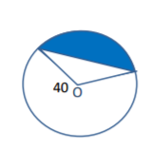
Example 5: Find the area of a segment of a circle if the central angle of the segment is 165º and the radius is 40.

Example 6: Find the area of a segment of a circle if the central angle of the segment is 50º and the radius is 15.
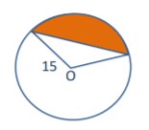

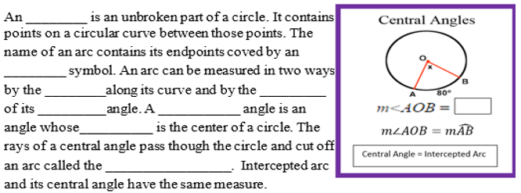
4 – 4 Central and Inscribed Angles
arc

arc-like
measure
length
central
central
vertex
intercepted arc

Example 1
Find each angle and arc measures.
1.
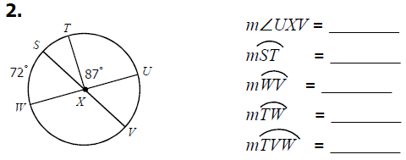

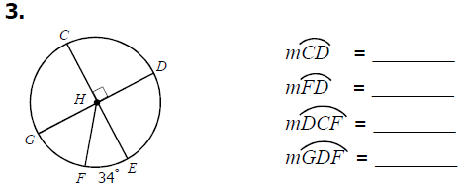
2.

Example 2
Find the measure of x and each arc measure.
1.

2.

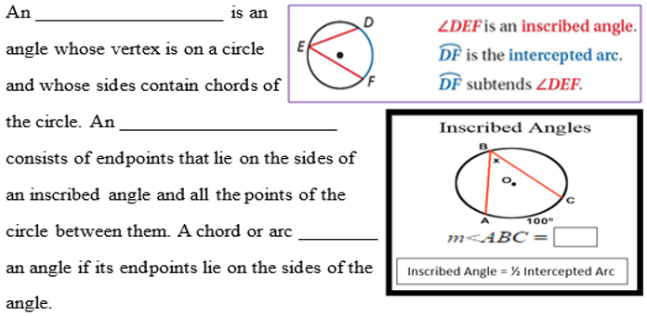
inscribed angle

intercepted arc

subtends

Example 3
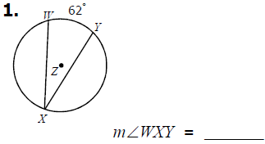
Find each angle and arc measure.

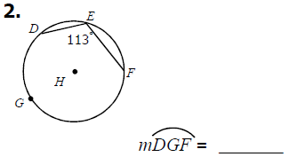

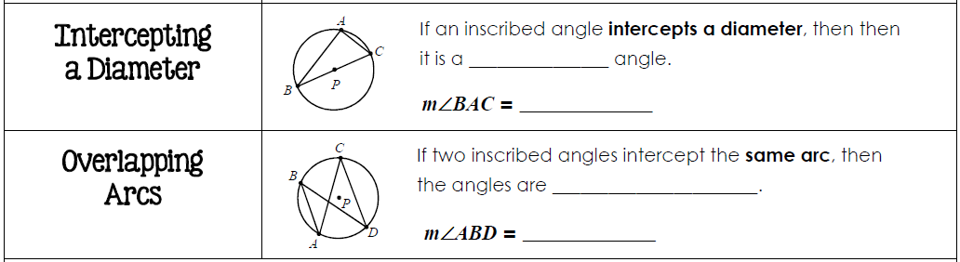

Example 4
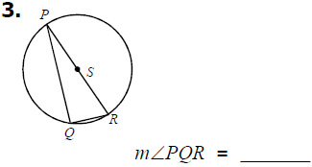
Find each angle measure.
1.

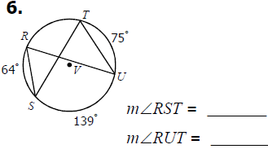
2.

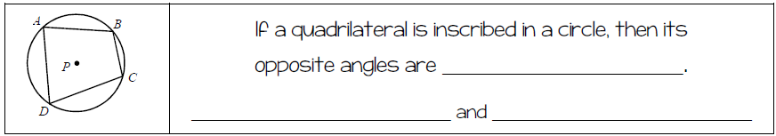

Example 5
Find each value or measure.
1.
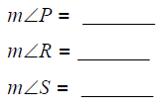
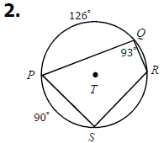

2.
