Unit 3
Right Triangles trigonometry

Name: _________________________
Period: _____

2018 – 2019 Geometry
Pebblebrook High School – Deuire
Vocabulary Builder
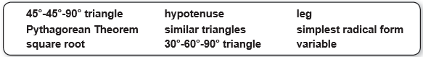
Choose the concept from the list below that best represents the item in each box.

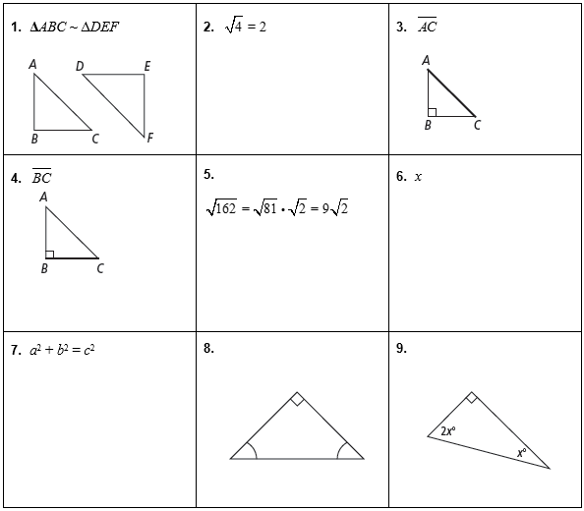

Draw a line from each word in Column A to its definition in Column B.
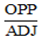
10. Sine

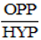
11. Cosine

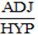
12. Tangent
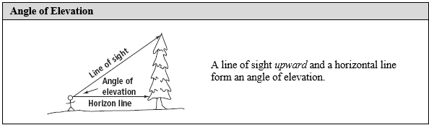

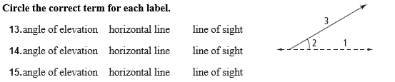

1 =

2 =

3 =

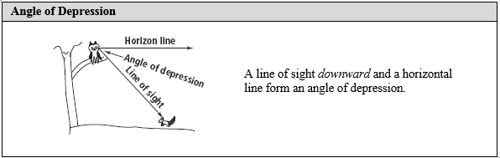

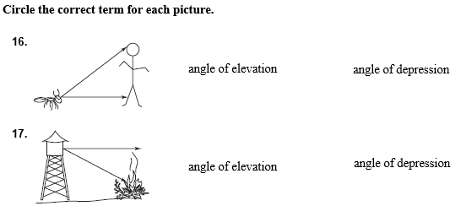

3 - 1 Trigonometric Ratios
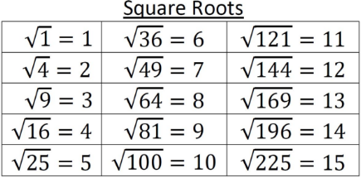
If the __square root__ of a number is a whole number, the original number is called a __perfect square__, which is a number multiplied by itself.
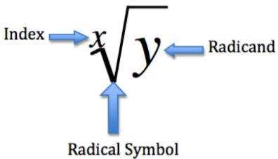

A __radical expression__ is an expression that contains a square root. The number under the radical sign is called the __radicand__.
To simplify a radical expression, make sure that the radicand has no __perfect square__ factors other than 1.
Example 1
Simplify each expression.

Example 2
Simplify each expression.

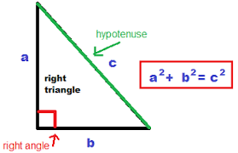
The Pythagorean Theorem is probably the most famous mathematical relationship. The theorem states that in a __right triangle__, the sum of the squares of the lengths of the legs __equals__ the square of the length of the __hypotenuse__.
The Pythagorean Theorem gives you a way to find unknown __side lengths__ when you know a triangle is a right triangle.
Example 3
Find the value of x. Give your answer in simplest radical form.
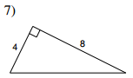
13)

14)
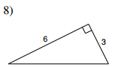

15)
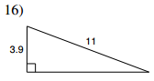

We can use the Pythagorean Theorem to determine if 3 given numbers represent the sides of a right triangle.
Example 4
Do these sets of numbers represent the sides of a right triangle?
1. 5, 5, 10
2. 9, 12, 15

4. 4, 6, $\sqrt{40}$
3. 6, 8, 10

Similar Triangles – Dividing into 2 similar sub-triangles

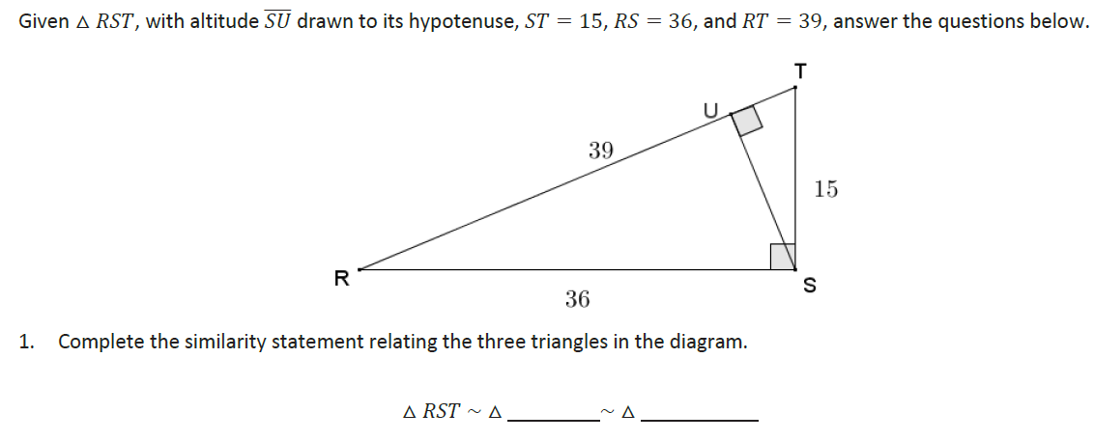
Example 5

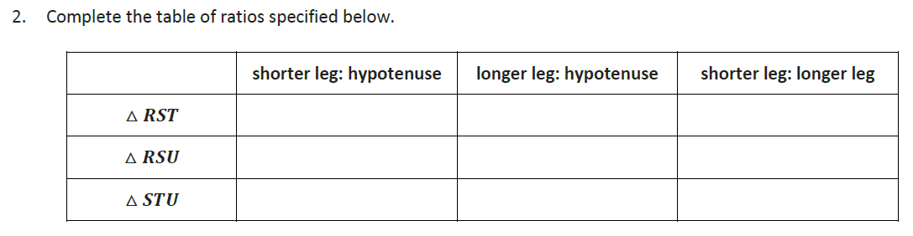

3. Use the values of the ratios you calculated to find the length of $\overline{SU}, \overline{RU},$ and $\overline{TU}.$

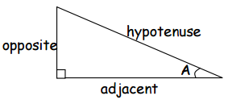
We will further study right triangles by looking at trigonometric values as defined by ratios of the sides of a right triangle. The side labeled __hypotenuse__ is always opposite the right angle of the right triangle. The other two sides of the right triangle are determined by the angle that is being discussed. The _adjacent_ side will always make up part of the angle that is being discussed and cannot be the hypotenuse. The side of the right triangle that DOES NOT form part of the discussed angle is called the __opposite__ side.
Example 6
Identify the opposite, adjacent, and hypotenuse of the following triangles.

Example 7
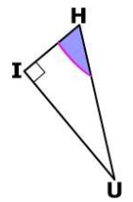
Identify the opposite, adjacent, and hypotenuse of the following triangles.
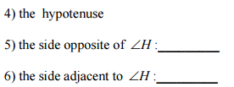

A __trigonometric ratio__ is a ratio of two sides of a right triangle.
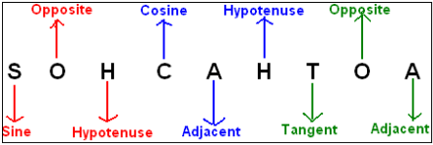
Thinking __SOH CAH TOA__ can help you remember these ratios.

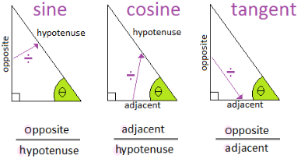
Using the ratios below, you can find the __length__ of any side of a __right__ triangle if you know one __acute__ angle and any other side.

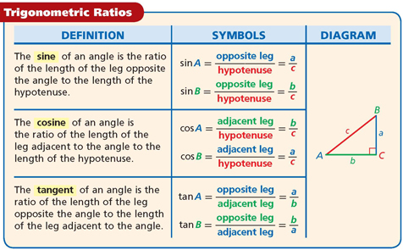

Example 8

Write each trigonometric ratio as a fraction and as a decimal rounded to the nearest hundredth.
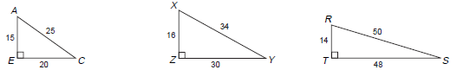

Example 9
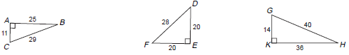
Write each trigonometric ratio as a fraction and as a decimal rounded to the nearest hundredth.

3 - 2 Finding Missing Sides and Angles of a Right Triangle
Sine, Cosine, and Tangent are trigonometric _functions_.
The _angle_ of each function is a(n) _input_ measure.
For each trigonometric function, every acute angle measure produces a different __output__, or value of the function.
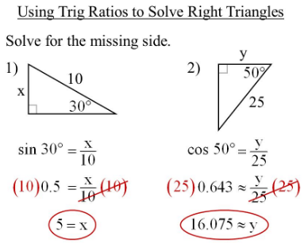

Example 1
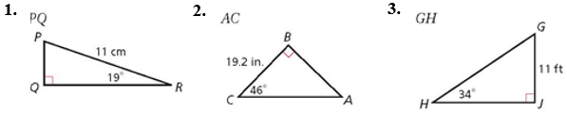
Find each length. Round to the nearest hundredth.

x
x

x

Example 2
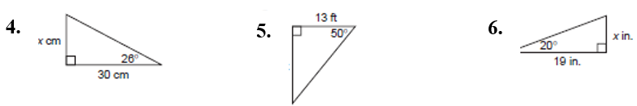
Find each missing length. Round to the nearest hundredth.

x

Using an inverse trigonometric function, such as __sin⁻¹__, __cos⁻¹__, __tan⁻¹__ allows you to determine an unknown angle measure given sides of right triangle.

Example 3
Find the missing measure. Round to the nearest tenth.
1.
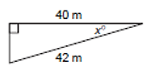
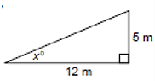
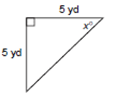
3.
2.

Example 4
Find the missing measure. Round to the nearest tenth.
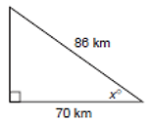
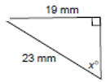
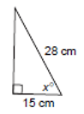
6.
5.
4.

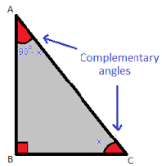
3 – 3 Sine and Cosine of Complementary Angles
The sum of the measures of the interior angles of a triangle is __180⁰__. Every right triangle has one right angle, so the sum of the measures of the two acute angles in any right triangle must be equal to __90⁰__. Angles that add up to 90˚ __complementary__ angles.

In a right triangle, the __opposite angles__ for one acute angle is the adjacent leg for the other acute angle. So, the sine of one acute angle is equal to the __cosine__ of its complement, and vice versa.
$$\sin{A}=cos⁡(90-A)$$
$$\cos{B}=sin⁡(90-B)$$

Example 1
Write each trigonometric function in terms of its complement.

1. $\sin{64}$˚
2. $\cos{84˚}$
3. $\cos{38}$ ˚
4. $\sin{24}$ ˚
5. $\cos{72}$ ˚
6. $\sin{45˚}$

Example 2
Write each trigonometric function in terms of its complement.

1. $\sin{22}$˚
2. $\cos{65˚}$
3. $\cos{44}$ ˚
4. $\sin{32}$ ˚
5. $\cos{25}$ ˚
6. $\sin{15˚}$

Example 3
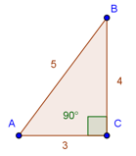
Find the missing values.
a. $\sin{A}=_______$ b. $\sin{B}=_______$
b. $\cos{A}=_______$ d. $\cos{B}=_______$

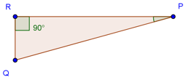
a. $\sin{P}=_______$ b. $\sin{Q}=_______$
b. $\cos{P}=_______$ d. $\cos{Q}=_______$

m∠P = 30˚

What do you notice about the relationship between sine and cosine?
__________________________________________________________________________________________
__________________________________________________________________________________________
__________________________________________________________________________________________

Example 4
Write each trigonometric expression.

Example 5
Draw ΔABC where ∠ACB = 90˚. AC = 5 and CB = 12.
- What is the length of AB?

- What is cos A?

c. What is sin B?

Draw ΔHAT where ∠H = 90˚ and $\tan{A}= \frac{12}{35}$.
- What is the length of AT?

- What is sin A?

c. What is cos T?

Draw ΔXYZ where ∠Y = 90˚. XY = 8 and YZ= 6.
- What is the length of XZ?

- What is cos X?

c. What is sin Z?

3 – 4 Solve Right Triangles
Now that we know how to write the 3 trigonometric functions of a right triangle, we can use these ratios to __solve__ a right triangle.
Solving a right triangle means that we use given __side lengths__ and __angle__ measures to calculate missing sides and angle measures.
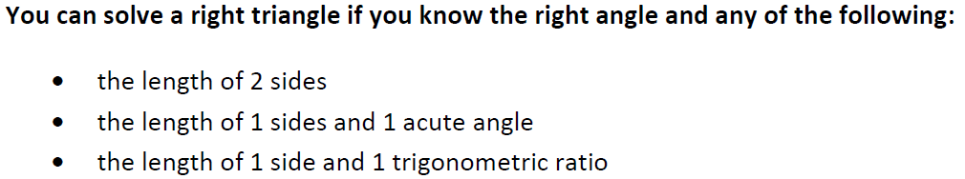

Example 1
Find ALL the unknown measures. Round lengths to the nearest hundredth and angle measures to the nearest degree.
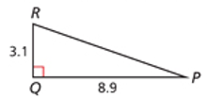
1.

a. $\overline{RP}=_______$
b. $∠P=_______$
c. $∠R=_______$

Example 2
Find ALL the unknown measures. Round lengths to the nearest hundredth and angle measures to the nearest degree.
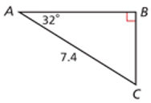
2.

a. $\overline{BC}=_______$
b. $\overline{AB}=_______$
c. $∠C=_______$

A(n) __angle of elevation__ is the angle formed by a horizontal line and the line of sight to an object ABOVE the horizontal line.
A(n) __angle of depression__ is the angle formed by a horizontal line and the line of sight to an object BELOW that horizontal line.
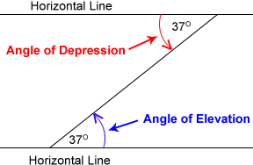
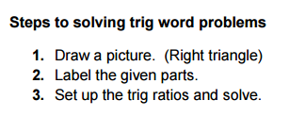

Example 3
Describe each angle as it relates to the situation in the diagram.
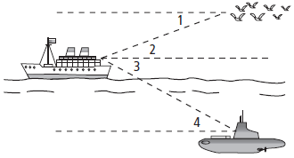

Example 4
Describe each angle as it relates to the situation in the diagram.
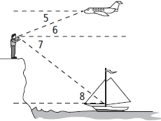

Example 5
Find the value of x. Round to the nearest tenth.

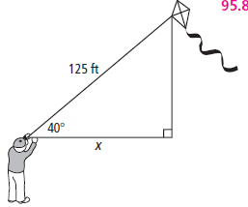
1.

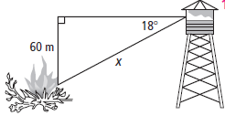
2.

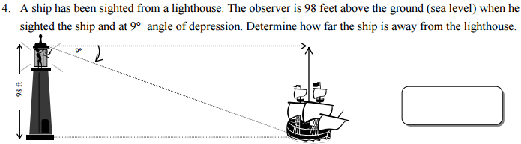
3.

Example 6
Find the value of x. Round to the nearest tenth.

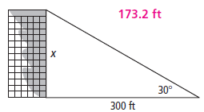

1.

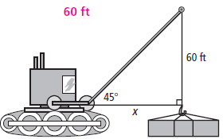
2.

3.
