Part A: 2.1 – 2.4

Name: _________________________
Unit 2A: Similarity, Congruence and Proofs
Period: _____

2018 – 2019 Geometry
Pebblebrook High School – Deuire
Vocabulary Builder
Choose the word from the list below that best matches each sentence.
intersect parallel perpendicular transversal
1. Two lines in the same plane that never intersect _________________________
2. A line that crosses two lines in the same plane at two different points _____________________________
3. What two lines that cross at a point do _________________________
4. Two lines that cross at a $90°$ angle _________________________

Use a word from the list above to complete each sentence.
5. The symbol $⊥$ is used to show that lines are _____________________________.
6. If two lines are parallel to the same line, they are _________________________ to each other.
7. The symbol $∥$ is used to show that lines are ____________________.
8. Parallel lines are lines that never ______________________.

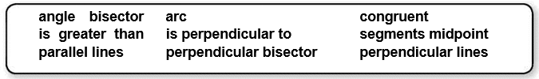
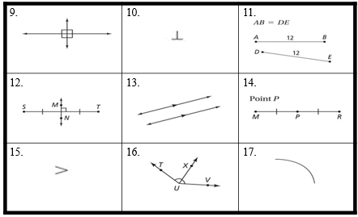

2-1 Parallel Lines and Transversals

A line that intersects two or more lines in a plane
At a different point is called a transversal.
Eight angles are formed by a transversal and two lines.
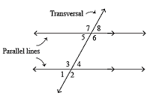

Types of Angles
Angle | Definition | Examples
Interior | lie between the two lines
Alternate Interior | On opposite sides of the transversal
Consecutive Interior | On same side of the transversal
Exterior | Lie outside the two lines
Alternate Exterior | On opposite sides of the transversal

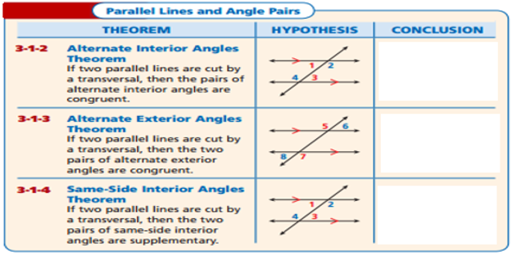

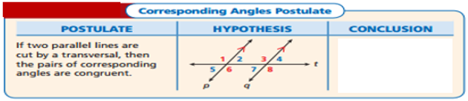

Example 1
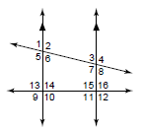
Identify each pair of angles as alternate interior, alternate exterior, consecutive interior, or vertical.

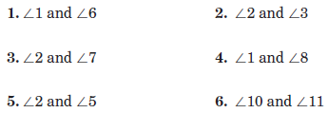

Example 2
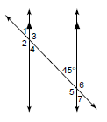
Find the measure of each angle. Give a reason for each answer.
7.
8.

9.
10.

Suppose two lines in a plane are cut by a transversal. With enough information about the angles that are formed, you can decide whether the two lines are parallel.

If two parallel lines are cut by a transversal then the following pairs of angles are congruent:
- ___corresponding angles_______
- ___alternate interior angles____
- ___alternate exterior angles____
If two parallel lines are cut by a transversal then consecutive interior angles are supplementary.

Example 3
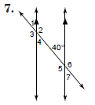
Find the measure of each numbered angle.
11.
$$m∠1$$
$$m∠2$$
$$m∠3$$
$$m∠4$$
$$m∠5$$
$$m∠6$$
$$m∠7$$
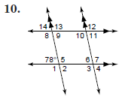
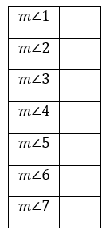
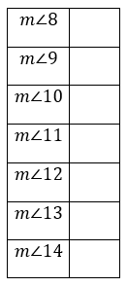
12.

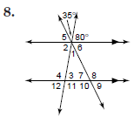
13.

Example 4
Find the value of x.

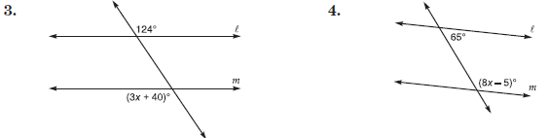

2-2 Congruent Triangles

Geometric figures are congruent if they are the same shape and size. Corresponding angles and corresponding sides are in the same position in polygons with an equal number of sides. Two polygons are congruent if and only if their corresponding sides and angles are congruent.
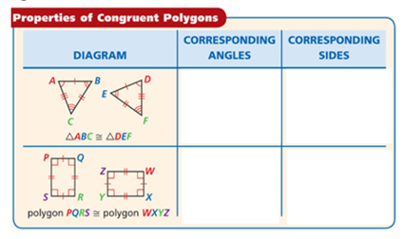

Example 1
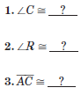
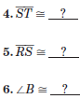
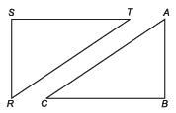
If ΔRST ≅ ΔABC, use arcs and slash marks to show the congruent angles and sides. Complete the congruence statement.

Example 2
Show that the polygons are congruent by identifying all congruent corresponding parts. Then write a congruence statement.
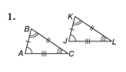

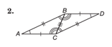

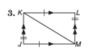

- Rigid motion, also known as an isometry, preserve angle measure and lengths of line segments. This means that when a rigid motion is performed on a figure, the corresponding sides and angles of the image and the pre-image are congruent.

- You can determine whether some figures are congruent by determining what type of transformation can be applied to one figure to produce the other figure.

Example 3
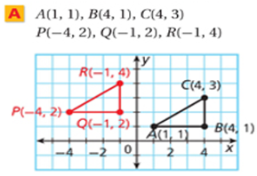
Determine whether the polygons with the given vertices are congruent.
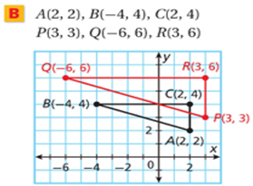

Determine whether the polygons with the given vertices are congruent.
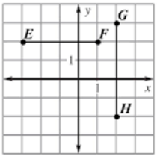

- Two triangles are congruent if all of their corresponding angles are congruent and all of their corresponding sides are congruent. However, you do not need to know the measure of every side and angle to show that two triangles are congruent.
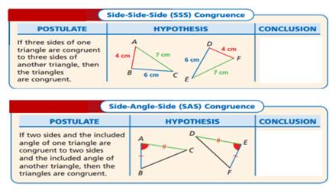

Example 4
Determine whether each pair of triangles is congruent. If so, write a congruence statement and explain why the triangles are congruent.

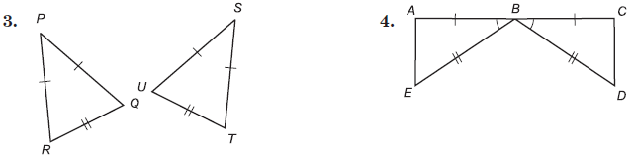

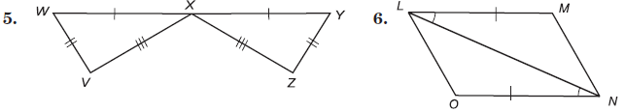

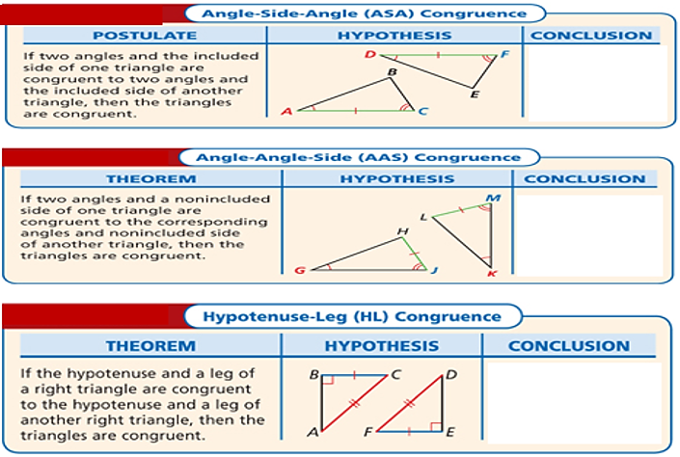

Example 5
Determine whether each pair of triangles is congruent. If so, write a congruence statement and explain why the triangles are congruent.
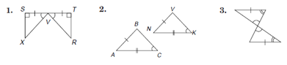

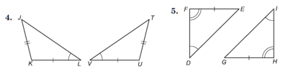

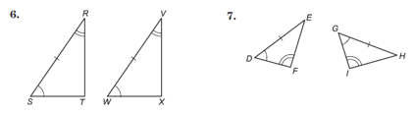

Example 6
Name the additional congruent parts needed so that the triangles are congruent by the postulate or theorem indicated.
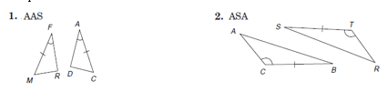

2-3 Similar Figures
- A ratio is a comparison of two quantities. The ratio of a to b can be expressed as $\frac{a}{b}$, where b is not = 0.

- An equation stating that two rations are equal is a proportion.

- In any true proportion, the cross products are equal. So $\frac{a}{b} = \frac{c}{d}$ if and only if ad = cb.

Example 1
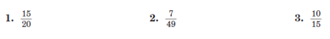
Write each ratio in simplest form.

Solve each proportion.

- Figures that are similar have the same shape but not necessarily the same size.

- To prove a figure is similar, their corresponding angles must be congruent and their corresponding sides must be proportional.

Example 2
Determine whether each pair of polygons are similar.
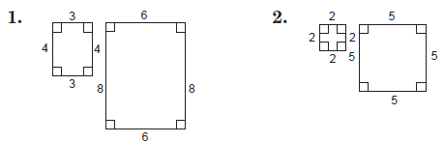

If each pair of polygons is similar, find the values of x and y.

- A similarity statement can be written to show that polygons are similar.
- The symbol $\sim$ means similar to.
- A similarity ratio is a ratio that compares the lengths of the corresponding sides of two similar polygons. The ration is written in the same order as the similarity statement.

Example 3
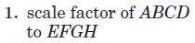
If quadrilateral ABCD is similar to quadrilateral EFGH, find each of the following.
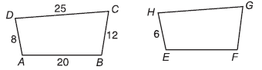

Example 4
Each pair of polygons is similar. Find the value of x.

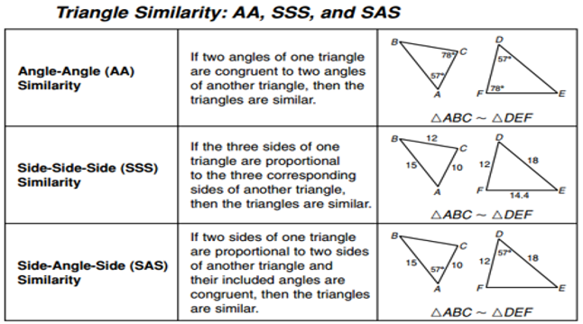

Example 5
Determine whether each pair of triangles is similar. If so, tell which similarity test is used and complete the statement.
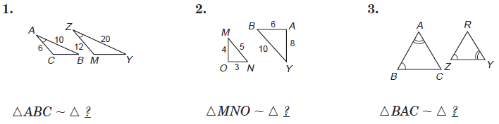

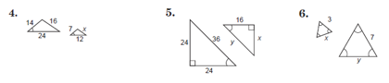
Find the value of each variable.

Triangle Mid-Segment Theorem
If a segment joins the midpoints of two sides of a triangle, then the segment is parallel to the third side, and is half its length.

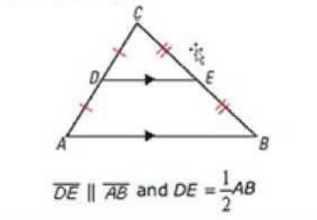

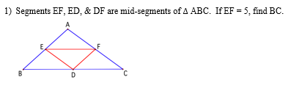
Example 6

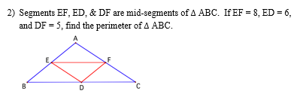

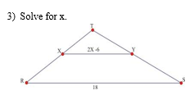

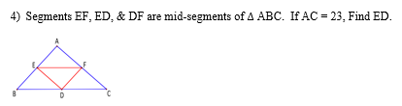

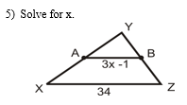

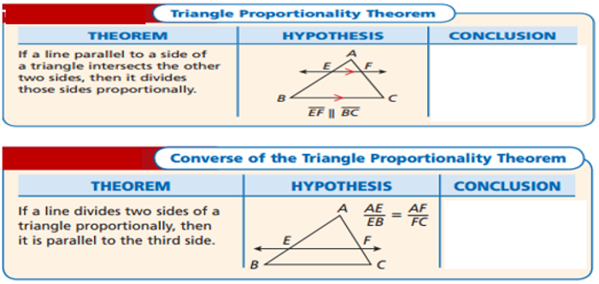

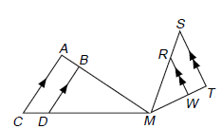
Example 7
Complete each proportion.

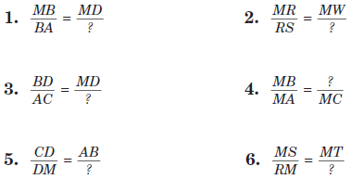

Example 8
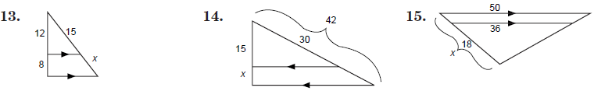
Find the value of x.
7.
9.
8.

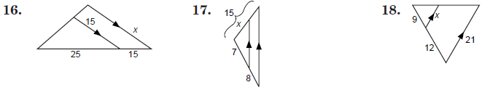
12.
11.
10.

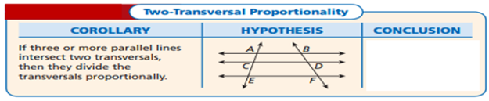

Example 9
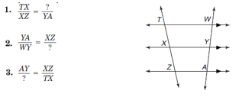
Complete the proportion.

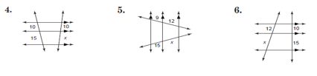
Find the value of x.

2-4 Dilations and Similarity
- A dilation is a transformation that moves the points of a line, line segment, or figure either toward or away from a point called the center of dilation. The center of dilation can be any point inside the figure, on the figure, or outside the figure.
- Dilation produce similar figures.
- Like rigid motions, dilations preserve angle measure. Unlike rigid motions, dilation do not preserve the length of line segments. Instead, they produce a figure with sides that are proportional to the sides of the pre-image.
- To dilate, multiply the coordinates of the pre-image by a scale factor to obtain the coordinates of the image.

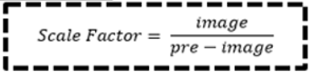

- If the scale factor is greater than 1, then it is a(n) enlargement. If the scale factor is less than 1, then it is a reduction.

Example 1
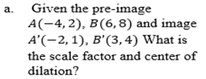
Find the center of dilation and scale factor.

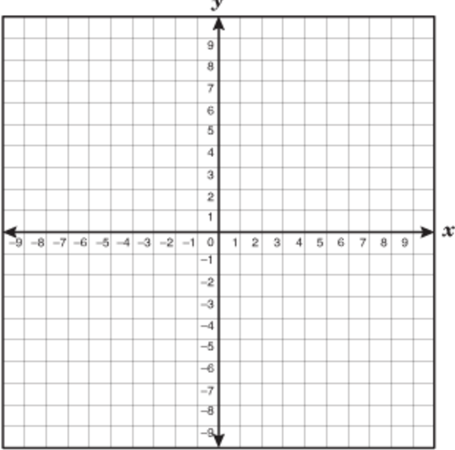

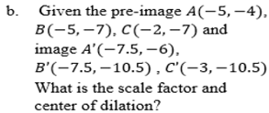

Example 2
Find the center of dilation and scale factor.
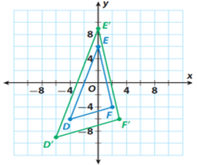

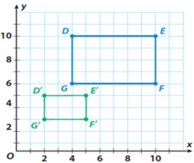

A vertical scaling multiplies/divides every y-coordinate by a constant while leaving the x-coordinate unchanged. A horizontal scaling multiplies/divides every x-coordinate by a constant while leaving the y-coordinate unchanged. The vertical and horizontal scaling can be combined into one question.

Example 3
