

Unit 5: Geometric and Algebraic Connections

GSE Geometry



April 10, 2017

Pebblebrook Math Department

**Vocabulary Builder**

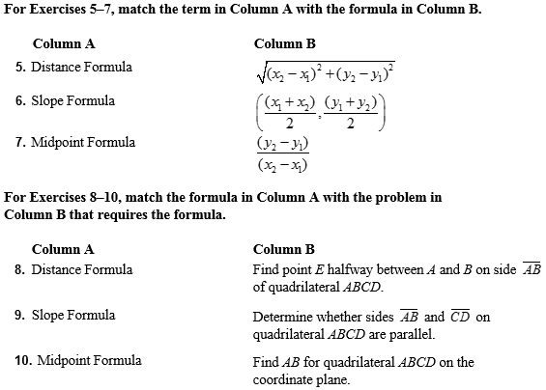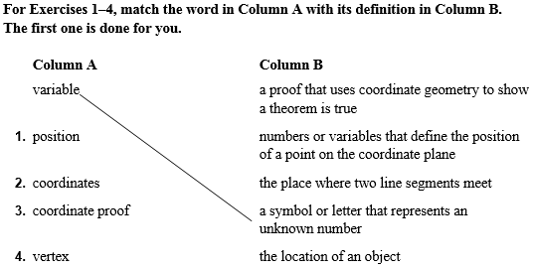

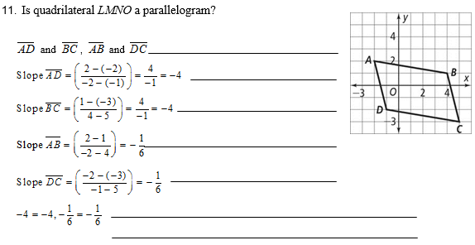

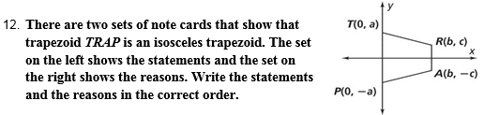

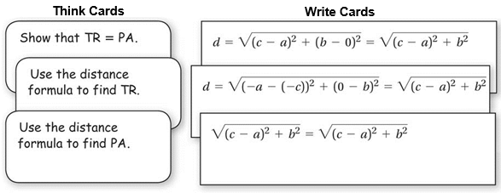

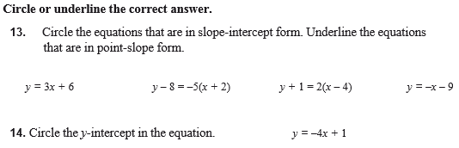

**x-axis y-axis coordinates x-intercept y-intercept**

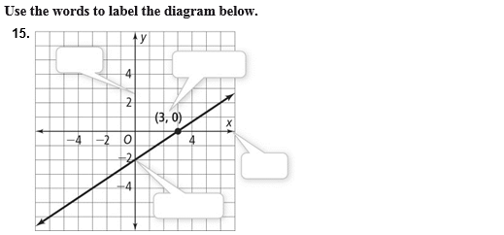

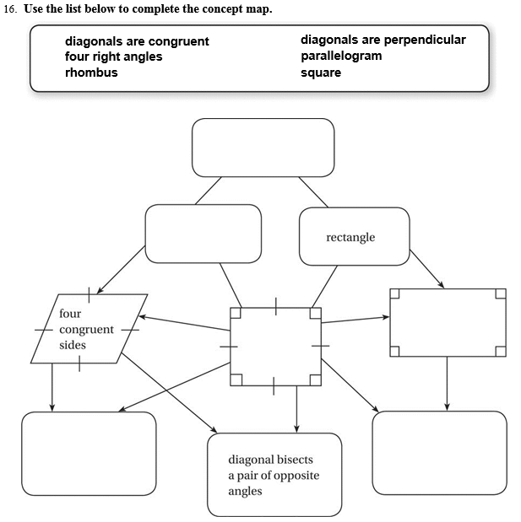

**5 – 1 Slope and Equations of Lines**

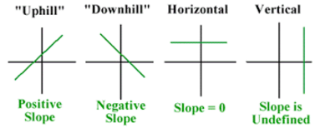The _________________ of a line is the vertical change divided by the horizontal change.

 

Another way to think of slope is

To find the slope of a line containing two points, use the following formula.

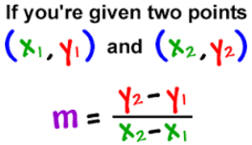

The slope of a vertical line, where x1 = x2 is _________________. Two lines have the same slope if and only if they are _____________________ and ________________________. Two non-vertical lines are _______________________________ if and only if the product of their slopes is __________.

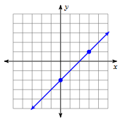**Example 1**

Find the slope of the line.

1.



2.

Find the slope of a line parallel and perpendicular to each given line.

4.

3.

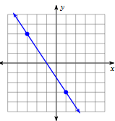

Find the slope of the line.

5.

6.

Find the slope of a line parallel and perpendicular to each given line.

8.

7.

**Writing Equations of a Line**

|  |  |
| --- | --- |
| Writing Equations of Lines |  |
|  |
|  |

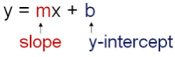**Example 2**

Write the equation of each line in slope-intercept form.

The line with slope 3 that passes through (0, 6)

______________________________

3.

2.

1.

Passes through (8, 6) and (-3, -3)

______________________________

______________________________



Write the equation of each liine in slope-intercept form.

______________________________

5.

The line with slope = -2, goes through the point at (2, -4)

______________________________

Passes through (-5, 10) and (2, 4)

______________________________

4.

6.

**Writing Equations of a Line that are PARALLEL or PERPENDICULAR to another and given a point**

|  |  |
| --- | --- |
| Parallel and Perpendicular |  |
|  |

**Example 3**

1.

Write a line parallel to the line $2x+y=3$ and passes through the point $\left(-2, 5\right)$.

2.

Write a line perpendicular to the line $y=\frac{1}{2}x-2$ and passes through the point $\left(1,0\right)$.



3.

Write a line parallel to the line $y=3x-5$ and passes through the point

$\left(-5, -2\right)$**.**

4.

Write a line perpendicular to the line $y=-3x+2$ and passes through the point $\left(6, 5\right)$**.**



Write the equation of each line in slope-intercept form.

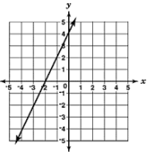

______________________________

Passes through (4, -6) and (-1, 5)

______________________________

The line with slope = 5, goes through the point at (2, -5)

______________________________

1.

3.

2.

4.

Write a line parallel to the line $y=-4x+1$ and passes through the point $\left(2, -1\right)$.

5.

Write a line perpendicular to the line $2x+3y=9$ and passes through the point $\left(6,-1\right)$.



Write the equation of each line in slope-intercept form.

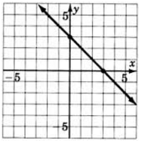

______________________________

Passes through (2, 3) and (-7, 8)

______________________________

The line with slope = -4, goes through the point at (0, 5)

______________________________

3.

1.

2.

4.

Write a line parallel to the line $y=-x-7$ and passes through the point $\left(-4, -4\right)$.

5.

Write a line perpendicular to the line $y=-3x+2$ and passes through the point $\left(6, 5\right)$.

**5 – 2 Coordinate Proofs**

___________________________________ can be used to find the diagonal distance on a coordinate grid. The diagonal distance is in fact the ________________________ of the right triangle.

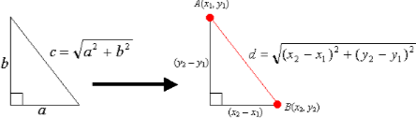

The method of finding the distance between two points requires that the diagram be drawn on grid paper which may be neither available nor convenient. Another way of finding the distance between two points with known coordinates is the use the _____________________________________. The distance formula is the _____________ of the square of the ________________ between the x-coordinates of the two points plus the square of the _____________________ between the y-coordinates of the two points.

**Example 1**

Use the distance formula to find the distance between the given points.

$\left(1, 4\right) and (-2, 3)$

1.



Use the distance formula to find the distance between the given points.

2.

$$\left(10, 5\right) and (40,45)$$

Coordinate Geometric Proofs

|  |  |  |
| --- | --- | --- |
| **Slope** | **Midpoint** | **Distance** |
| We use the slope to show parallel and perpendicular lines | We use midpoint to show line segments bisect each other. | We use distance to show line segments are equal |

|  |
| --- |
| **Proving a Triangle is a Right Triangle** |
| **Method 1:** Show two sides of the triangle are perpendicular by demonstrating their slopes are opposite reciprocals.  **Method 2:** Calculate the distances of all three sides and then test the Pythagorean’s theorem to show the three lengths make the Pythagorean’s theorem true. |

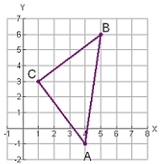**Example 2**

**Given:** The triangle with vertices $A\left(4, -1\right), B\left(5, 6\right), C(1, 3)$

**Show:** ΔABC is an isosceles right triangle.

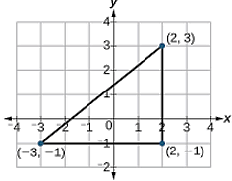



Prove that the polygon with coordinates $A\left(-3, -1\right), B\left(2, -1\right), C(2, 3)$ is a right triangle.

|  |
| --- |
| **Proving a Quadrilateral is a Parallelogram** |
| **Method 1:** Show that the diagonals bisect each other by showing the midpoints of the diagonals are the same.  **Method 2:** Show both pairs of opposite sides are parallel by showing they have equal slopes.  **Method 3:** Show both pairs of opposite sides are equal by using distance  **Method 4:** Show one pair of sides is both parallel and equal. |

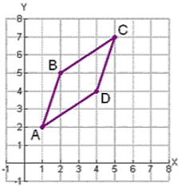**Example 3**

Prove that the quadrilateral is a parallelogram with the coordinates

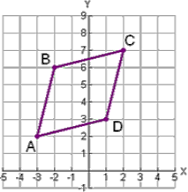

Prove that the quadrilateral is a parallelogram with the coordinates $A\left(-3, 2\right), B\left(-2, 6\right), C\left(2, 7\right), D(1, 3)$

|  |  |  |
| --- | --- | --- |
| Using Coordinate Geometry to Prove Rectangles, Rhombi, and Squares | | |
| **Rectangle**   * Use Slope to show lines are Perpendicular * Use Distance Formula to find congruent lengths | **Rhombus**   * Use Slope to show Diagonals are perpendicular * Use Distance Formula to find congruent segments | **Square**   * Use Slope to show lines are perpendicular * Use Distance Formula to find congruent lengths |

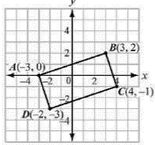**Example 4**

Prove that the quadrilateral with the coordinates $A\left(-3,0\right), B\left(3,2\right), C\left(4,-1\right), D(-2,-3)$ is a rectangle.

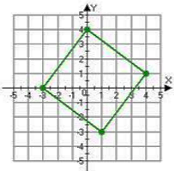  


Prove that the quadrilateral with the coordinates $A\left(-3,0\right), B\left(0,4\right), \left(4,1\right), D(1,-3)$ is a square.



Find the distance between the pair of points. Round your answer to the nearest tenth, if necessary.



1.

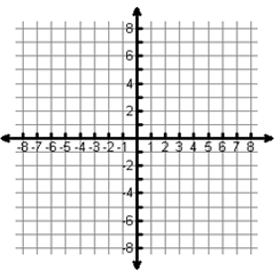Plot and label each point.

2.

Find the **length** of each side.

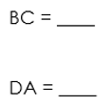 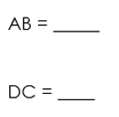

3.

 Find the length of each diagonal.



Find the slope of either sides or diagonal.

4.





What conclusion can you make about the name of this shape? __________________________________________________________________________________

5.

Plot and label each point. $A\left(0,0\right), B\left(6, -4\right), C\left(6, 4\right)$

6.

Find the **length** of each side.

 



7.

Classify the triangle. __________________________



Find the distance between the pair of points. Round your answer to the nearest tenth, if necessary.



1.

Plot and label each point.

2.

Find the **length** of each side.

 

3.

 Find the length of each diagonal.



Find the slope of either sides or diagonal.

4.





What conclusion can you make about the name of this shape? __________________________________________________________________________________

5.

Plot and label each point. $A\left(0,0\right), B\left(-4, 4\right), C\left(2, 8\right)$

6.

Find the **length** of each side.

 



7.

Classify the triangle. __________________________

**5 – 3 Perimeter and Area of Polygons**

A regular polygon is a polygon with congruent ___________ and __________.

You can use the ___________________________________ or the ____________________________ to find the length of sides and calculate the perimeter or area of a given polygon.

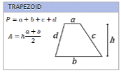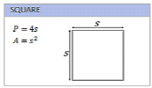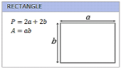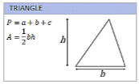

**Example 1**

Find the perimeter of the polygon.

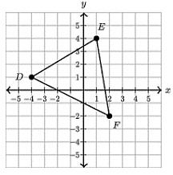



Find the perimeter of the polygon.

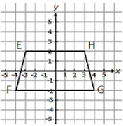

**Example 2**

Find the area of the polygon.

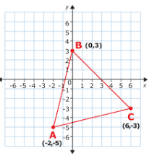



Find the area of the polygon.

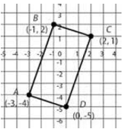



Find the perimeter and area of the polygon.

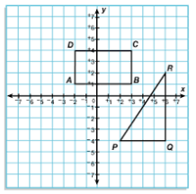



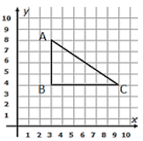Find the perimeter and area of the polygon.

1.

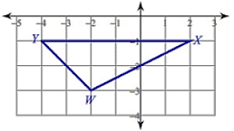

2.

**5 – 4 Midpoint and Direct Line Segments**

When two segments are congruent, we indicate that they are con congruent, or of equal length with _____________________________________.

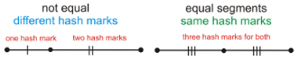

A ___________________ is a point on a line segment that divides it into two congruent segments. The midpoint should be _______________________ between the points on the segment connecting them.



**Example 1**

Find the midpoint.

$\left(3, 7\right)and \left(-2, 4\right)$

1.



Find the midpoint.

$\left(5, -2\right)and \left(6, 14\right)$

2.

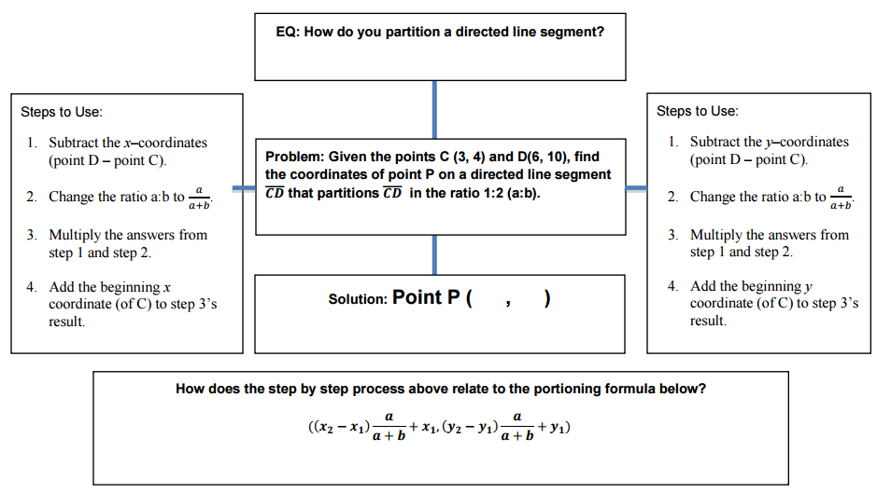**Partitioning a Directed Line Segment**

**Example 2**

1.

Find Point Z that partitions the directed line segment $\overline{XY}$ in a ratio of 5:3. $X\left(-2, 6\right) and Y(-10, -2)$

2.

Find the Point B that partitions the directed line segment $\overline{AC}$ at 1/5 the distance. $A\left(2, 9\right) and C(12, 14)$



1.

Find Point Z that partitions the directed line segment $\overline{XY}$ in a ratio of 2:3. $X\left(2, -4\right) and Y(7, 2)$.

2.

Find the Point B that partitions the directed line segment $\overline{AC}$ at 2/3 the distance. $A\left(3, 1\right) and C(3, 19)$.



Find Point Q that partitions the directed line segment $\overline{PS}$ in a ratio of 1:3. $P\left(-1, 2\right) and S(7, 14)$.

1.

2.

Find the Point F that partitions the directed line segment $\overline{EG}$ at 1/3 the distance. $E\left(-3, -4\right) and G(5, 0)$.



Find Point Q that partitions the directed line segment $\overline{PS}$ in a ratio of 1:2. $P\left(-2, 4\right) and S(7, -2)$.

1.

2.

Find the Point F that partitions the directed line segment $\overline{EG}$ at 1/4 the distance. $E\left(4, 4\right) and G(10, 6)$.

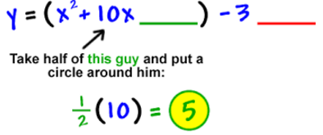**5 – 5 Equations of Circles**

You can solve any quadratic equation by _______________________________________. This method turns every expression x2 + *bx* into a perfect-square _________________________________.

**Example 1**

Complete the following squares.



2.

1.



Complete the following squares.

3.



4.

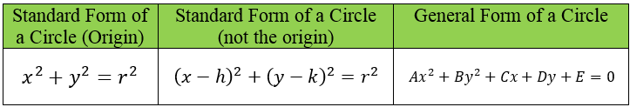

**Example 2**

1.

Write an equation of a circle with center $(3, -2)$ and a radius of 4.

2.

The center is (4, -1), and a point on the circle is (-1, -1).



Write an equation of a circle with center $(2, -9)$ and a radius of $\sqrt{11}$**.**

3.

The center is (2, 4) and a point of the circle is (-3, 16).

4.

**Example 3**

Find the coordinates of the center and the measure of the radius.

A circular skylight has a diameter with endpoints (-6, 32) and (2, 26). Find the center and radius of skylight.

1.

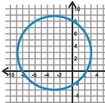 

3.

2.



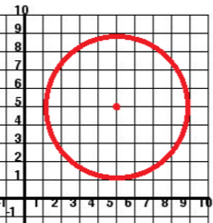Find the coordinates of the center and the measure of the radius.

A circular skylight has a diameter with endpoints (2, 8) and (12, 24). Find the center and radius of skylight.

4.



5.

6.

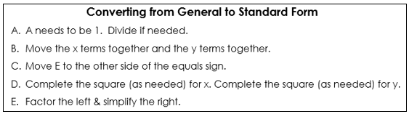

**Example 4**

Write the standard form of the equation for the circle. State the center and radius.

 

2.

1.



Write the standard form of the equation for the circle. State the center and radius.

 

4.

3.

**Example 5**

Write the general form of the equation for the circle. State the center and radius.



1.



Write the general form of the equation for the circle. State the center and radius.



2.

**Example 6**

Determine whether a point lies on the circle.

1.

The point lies on the circle centered at the origin with radius 5.

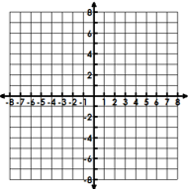

$A\left(-2, 1\right);Center C\left(0, 0\right);contains Point P(1, 2)$

2.



Determine whether a point lies on the circle.

3.

The point lies on the circle centered at the origin with radius 4.



4.



$A\left(5, 3\right);Center C\left(3, 1\right);contains Point P(3, -1)$

Find the value of c such that each expression is a perfect-square trinomial.

1.



2.

Write an equation of a circle with center (-4, 0) and a diameter of 10.

Given the standard form of a circle determine the general form, center, and radius of the circle.

3.



Write the standard form.

4.





Find the value of c such that each expression is a perfect-square trinomial.

1.



2.

Write an equation of a circle with center at the origin with a diameter of 12.

3.

The circle has its center at point (1, 2) and point A(1, 5) is on the circle. Is

point B(4, 2) on the circle?

Given the standard form of a circle determine the general form, center, and radius of the circle.



4.

Write the standard form.

5.

