Mathematics Department
Pebblebrook high school | GSE Geometry
EOC/Final Exam Review
GSE Geometry
Unit 1: Transformations in the Coordinate Plane
Term | Illustration | Definition
 | 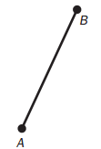 | A part of a line; it consists of two points and all points between them
 | 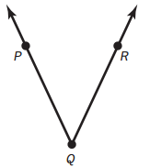 | Formed by two rays with a common endpoint
 | 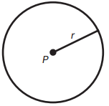 | The set of all points in a plane that are equidistant from a given point called the center; the fixed distance is the radius
 | 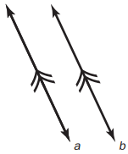 | Lines in the same plane that do not intersect
 | 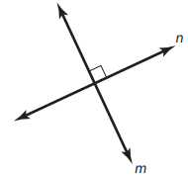 | Two lines that intersect to form right angles

- A ___________________________________ in a coordinate plane can be described as a function that maps ________________ points (inputs) to _______________ points (outputs.
- _______________________________, ______________________, and ____________________ all preserve distance and angle measure because, for each of those transformations, the pre-image and image are _______________.
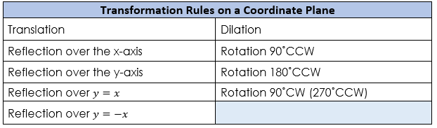
- Some types of transformations do not preserve distance and angle measure because the pre-image and image are _________________.

Unit 2: Similarity, Congruence, and Proofs
- A ________________________ is a transformation that changes the size of a figure, but not the shape, based on a ratio given by a ____________________ with respect to a fixed point called the _______________.
- When the scale factor is greater than 1, ______________________, the figure is made larger. When the scale factor is between 0 and 1, ________________, the figure is made smaller. When the scale factor is 1, the figure _____________________________.
- When a figure is transformed under a dilation, the ______________________ of the pre-image and the image have _____________________________, and the ____________________________________ of the pre-image and the image are ___________________________.
- So when a figure is under a dilation transformation, the pre-image and the image are _____________.
- When proving that two triangles are similar, it is sufficient to show that two pairs of corresponding angles of the triangles are congruent. This is called ________________________________________.
- A ____________________________________________ is a series of statements and reasons often displayed in a chart that works from given information, can be based on ___________________, or can be based on ____________________ or ____________________.
- A ______________________________________ also uses a series of statements and reasons that work from given information to the statement that needs to be proven, but the information is presented as running text in paragraph form.
- A _______________________ is a transformation of points in space consisting of a sequence of one or more translations, reflections, and/or rotations (in any order). This transformation leaves the _____________ and ___________ of the original figure unchanged.
- Two triangles are congruent if and only if their corresponding __________ and corresponding _______ are congruent. This is sometimes referred to as _____________, which means Corresponding Parts of Congruent Triangles are Congruent.
- You can use SSS, SAS, ASA, and AAS to show two triangles are congruent.
Triangle Congruence: _______  Congruence Statement: ______________ | 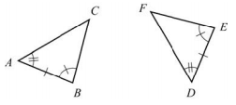
Triangle Congruence: _______  Congruence Statement: _______________ | 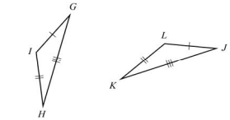
Triangle Congruence:________  Congruence Statement: ______________ | 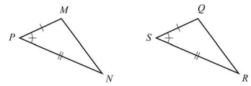
Triangle Congruence: _______  Congruence Statement: ________________ | 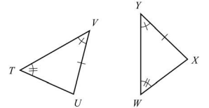

Some important KEY IDEAS about LINES and ANGLES
- _____________________  - _____________________  _____________________  - _____________________  _____________________  - _____________________  ____________________ | - Vertical Angles are Congruent  - If two parallel lines are cut by a transversal, then alternate interior angles formed by the transversal are congruent  - If two parallel lines are cut by a transversal, then corresponding angles formed by the transversal are congruent  - Points on a perpendicular bisector of a line segment are equidistant from both of the segment’s endpoints
Some important KEY IDEAS about TRIANGLES
- _____________________  _____________________  - _____________________  _____________________  - _____________________ | - The sum of the measures of angles of a triangle is 180˚  - If two sides of a triangle are congruent, then the angles opposite those sides are also congruent  - If a segment joins the midpoints of two sides of a triangle, then the segment is parallel to the third side and half its length.
Some important KEY IDEAS about PARALLELOGRAMS
- Opposite sides are congruent and opposite angles are congruent
- The diagonals of a parallelogram bisect each other
- If the diagonals of a quadrilateral bisect each other, then the quadrilateral is a parallelogram
- A rectangle is a parallelogram with congruent diagonals

Geometric Construction | Given Information | Construction
 | 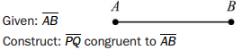 | 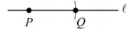
 | 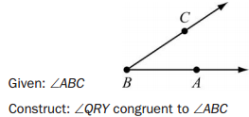 | 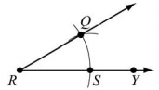
 | 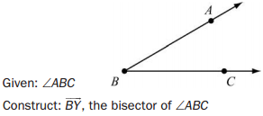 | 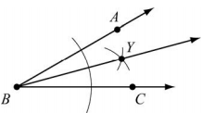
 | 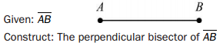 | 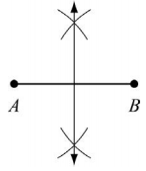
 | 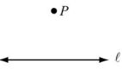  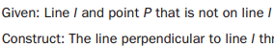 | 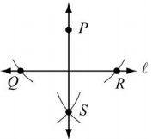
 | 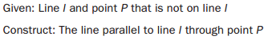 | 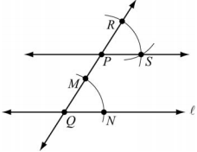
 | 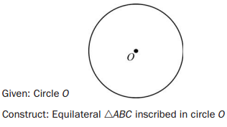 | 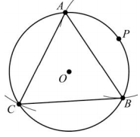
 | 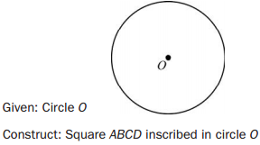 | 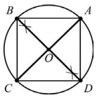
 | 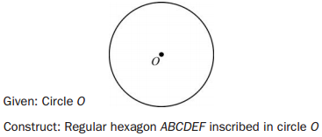 | 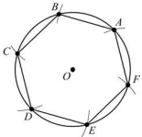

Name of Construction | Example | Point of Concurrency | Example
 | 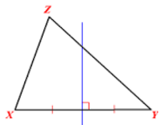 | Circumcenter | 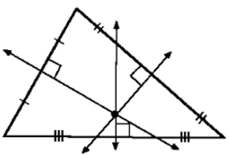
 | 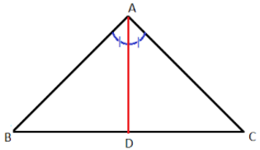 | Incenter | 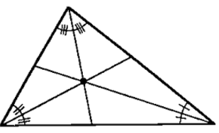
 | 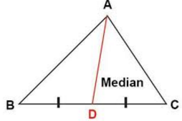 | Centroid | 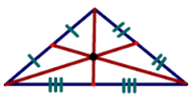
 | 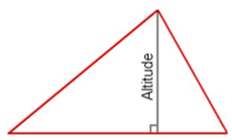 | Orthocenter | 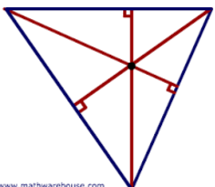

Unit 3: Right Triangle Trigonometry
- The trigonometric ratios ___________, _____________, and ____________ are defined as ratios of the lengths of the sides in a right triangle with a given acute angle measure.
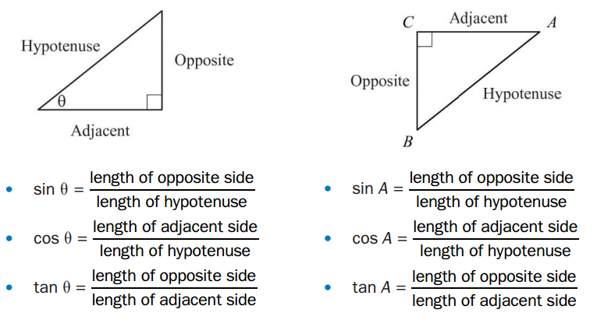

- The two acute angles of any right triangle are _________________________. As a result, if angles P and Q are complementary, $\sin{P= _________}$ and $\sin{Q= __________}$

- When solving problems with right triangles, you can use both ___________________________ and the ________________________. There may be more than one way to solve the problem, so analyze the given information to help decide which method is most efficient.

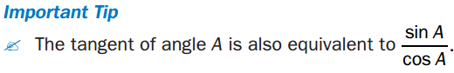

Unit 4: Circles and Volume

- A _____________ is the set of points in a plane equidistant from a given point, which is the center of the circle. All circles are __________.  - A _________ is a line segment from the center of a circle to any point on the circle. | 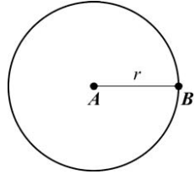
- A __________ is a line segment whose endpoints are on a circle. | 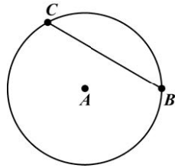
- A _______________ is a chord that passes through the center of a cirlce. The word diameter is also used to described the length. | 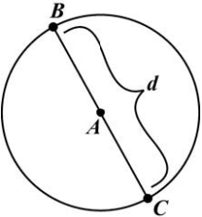
- A _______________________ is a line that is in the plane of a circle and intersects the cirle at exactly two points. Every chord lies on a secant line. | 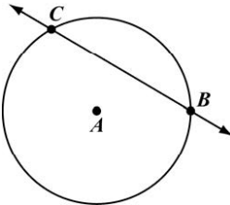
- A _______________________ is a line that is in the plane of a circle and intersects the circle at only one point, ____________________________. | 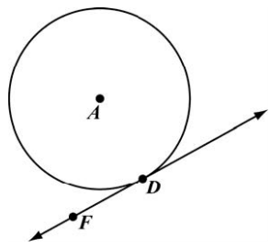
- A _____________________ is an angle whose vertex is at the center of a circle and whose sides are radii of the circle. The measure of a central angle of a circle is ___________ to the measure of the intercepted arc. | 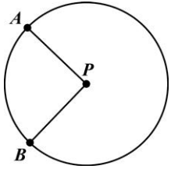
- An _________________________ is an angle whose vertex is on a circle and whose sides are chords of the circles. The measure of an angle inscribed in a circle is __________ the measure of the intercepted arc. | 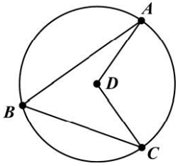

- ________________________________ is the distance around a circle. The formula is ___________, where r is the _______________ of the radius of the circle. Π is the ratio of circumference to _____________________ of any circle.
- An ________ is a part of the circumference of a circle. A ____________________ has a measure less than 180˚. A ____________________ is an arc that measures exactly 180˚. A ______________ has a measure greater than 180˚.
If a line is tangent to a circle, the line is ________________________ to the radius drawn to the point of tangency.  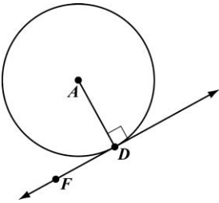 |  | Tangent segments drawn from the same point are __________________.  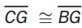  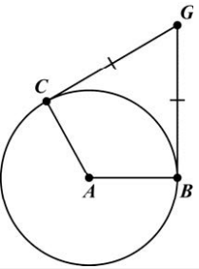
A _______________________ angle is an angled formed by two rays that are each tangent to a circle. The rays are perpendicular to the radii.  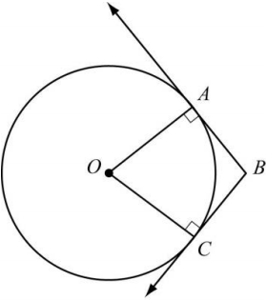 |  | When an inscribed angle intercepts a ________________, the inscribed angle has measure of ________.  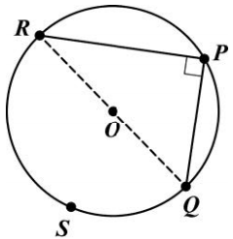  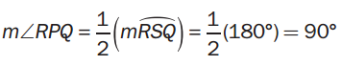
The measure of an angle formed by a tangent and a chord with its vertex on the circle is ___________ the measure of the intercepted arc.  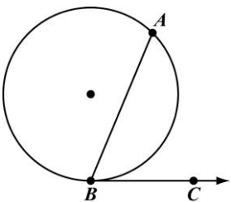  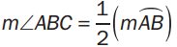 |  | When two chords intersect inside a circle, two pairs of _________________ are formed. The measure of any one of the angles is ___________________ of the measures of the arcs.  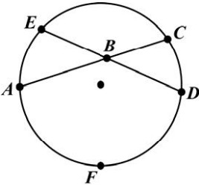  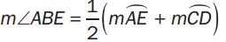
 | Angles outside a circle can be formed by the intersection of _____________________, _______________________________ or _________________________________. For all three situations the measure of the angle is _________ the difference of the measure of the larger intercepted arc and the measure of the smaller intercepted arc.
 | 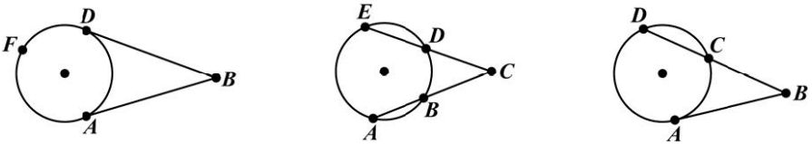

When ____________________ segments or ___________________________ segment intersect outside a circle, part of each secant segment is a segment formed outside the circle. The product of the length of each segment is equal to the product of the lengths of the other segment. | When two chords intersect inside a circle, the _______ of the lengths of the segments of one chord is equal to the product of the lengths of the segments of the other chord
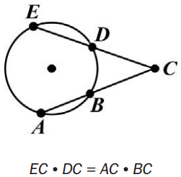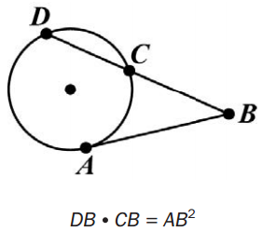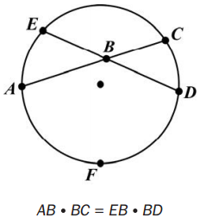

An ______________________________ is a polygon whose vertices all lie on a circle. This diagram shows a triangle, a quadrilateral and a pentagon each inscribed in a circle.
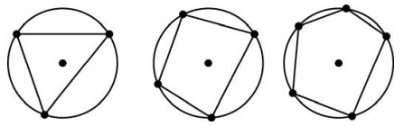
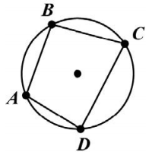
In a quadrilateral inscribed in a circle, the opposite angles are ____________________.
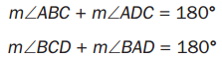

When a triangle is inscribed in a circle, the center of the circle is the ________________ of the triangle. It is equidistant from the vertices of the triangles  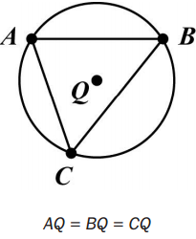 | An ____________________ is a circle enclosed in a polygon, where every side of the polygon is tangent to the circle. When a circle is inscribed in a triangle, the center of the circle is the _________  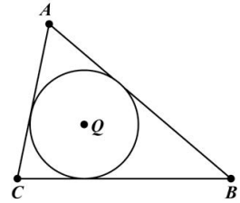

- _______________________ is a measure of the amount of space a circle covers. The formula ____________ is where r is the length of the radius of the circle.
 | Is a portion of the circumference of a circle | 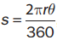 | 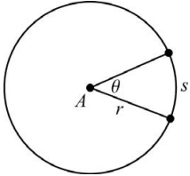
 | Is the region bounded by two radii of a circle and the resulting arc between them | 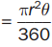 | 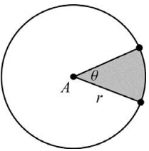

- To find the __________________________divide the number of degrees in the ____________________ of the arc by 360, and then multiply that amount by the ____________________ of the circle.

- To find the ___________________________ dive the number of degrees in the ____________________ of the arc by 360, and then multiply that amount by the ___________ of the circle.

- The _________________ of a figure is a measure of how much space it takes up. It is a measure of _______________.
 | Where r is the radius and h is the height  Where B is the area of the base and h is the height | 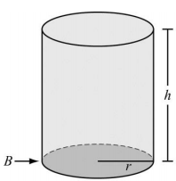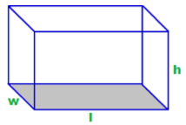
 | 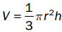  Where r is the radius and h is the height  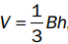  Where B is the area of the base and h is the height | 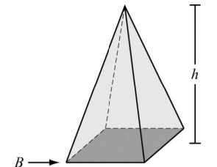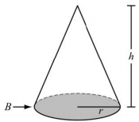
 | 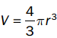  Where r is the radius | 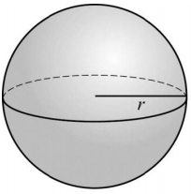

- ________________________ states that if two solids are between ____________ and all _______________________ at equal distances from their bases have equal _________. The solids have equal __________.
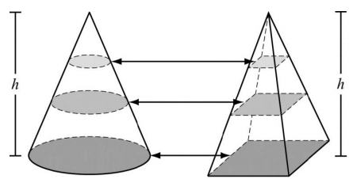
For example, the cone and pyramid above have the same height and the cross sections have the same area, so they have equal volumes.

Unit 5: Geometric and Algebraic Connections

- ___________________________ can be applied to describe real-life objects with geometric shapes.
- ______________ is the mass of an object by its volume.
- _____________________________ can be determined by calculating the _______________ of the number of people in an area and the area itself.
- Apply constraints to maximize or minimize the cost of a cardboard box used to package a product that represents a _________________________. Apply ______________ relationships of cylinders, pyramids, cones, and spheres.
- A ____________ is the set of points in a plane equidistant from a given point, or center, or the circle.
- The standard form of the equation of a circle is ______________________ where (h, k) is the ___________ of the circle and r is the __________ of the circle.
- Given the equation of a circle, you can verify whether a point lies on the circle by ________________ the coordinates of the point into the equation. If the resulting equation is _______, then the point lies on the figure. If the resulting equation is _____________, then the point does not lie on the figure.
- Given the ____________ and ____________ of a circle, you can verify whether a point lies on the circle by determining whether the _________________ between the given point and the center is equation to the ___________.
- To prove properties about special parallelograms on a coordinate plane, you can use the ____________________________, distance, and _____________ formulas.
- The ____________________________________ is used to find the coordinates of a point which partitions a directed line segment AB at the ratio of a:b.
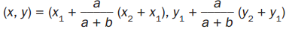

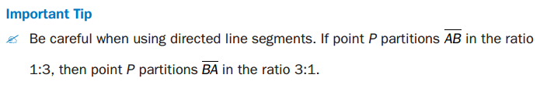
- The ________________ is used to find the coordinates of the midpoint.
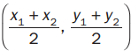

- The _________________________ is used to fine the length.
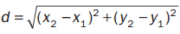

- The __________________ is used to find the slope of a line or line segment, given any two points. Slopes can be _____________, ______________, ______ or _____________.

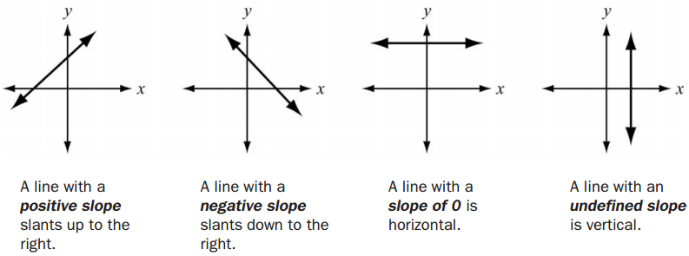

To prove properties about special parallelograms on a coordinate plane, you can use the midpoint, distance, and slope formulas:
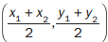 |  | 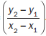

You can use properties of quadrilateral to help prove theorems
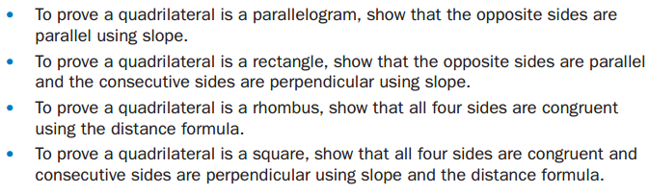

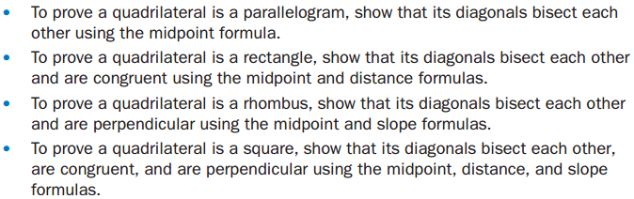

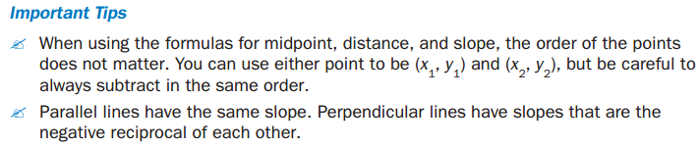

Unit 6: Applications of Probability

- 

 