Constructions in Geometry

Units 2 and 4

Name: ______________________________

Constructions of Lines and Angles
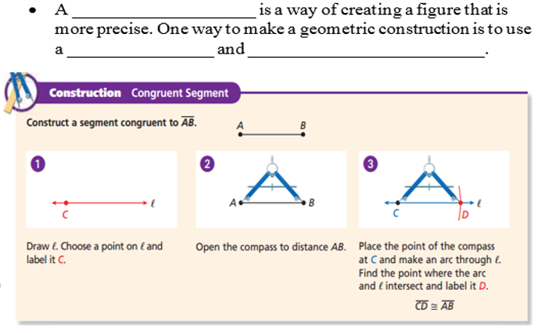
construction
straightedge
compass

Example 1
Construct a segment with an endpoint C and congruent to the segment AB.

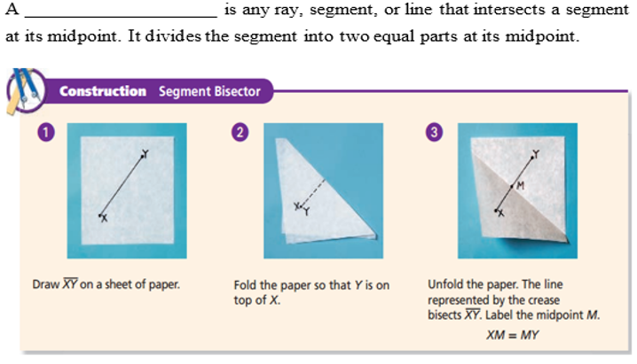
segment bisector

Example 2
Using patty paper, construct the segment bisector of CD.

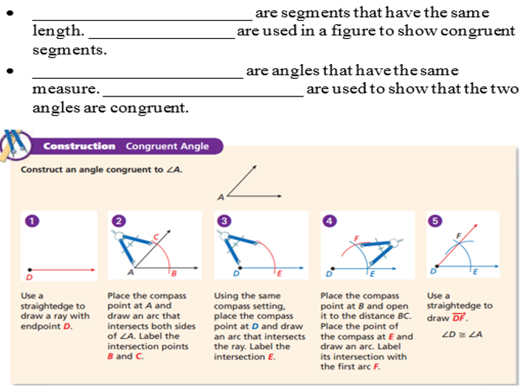
Arc marks
Congruent angles
Congruent segments
Tick marks

Example 3
Construct a congruent angle, and label it with points G, H, and I.

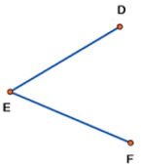

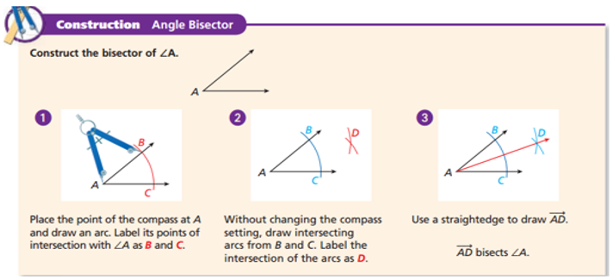

Example 4
Construct an angle bisector.

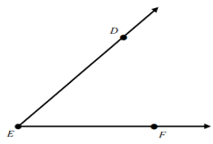

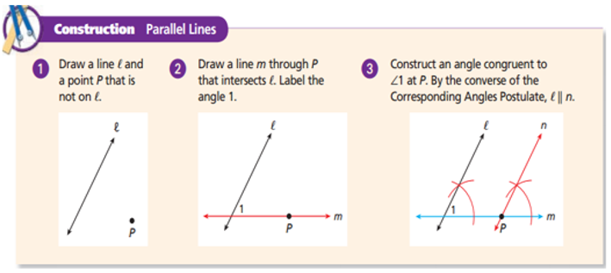

Example 5
Construct a parallel line.

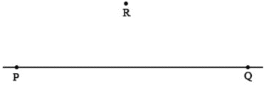

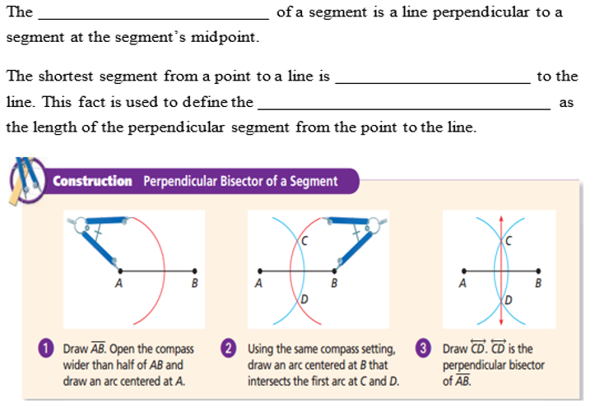
distance from a point on a line
perpendicular
perpendicular bisector

Example 6
Construct perpendicular line.

Construction of Polygons
- A regular polygon is a polygon that is equiangular and equilateral. This means that all its angles are the same measure and all its sides are the same length.

- The most basic example of a regular polygon is an equilateral triangle, a triangle with three sides and angles that are congruent.
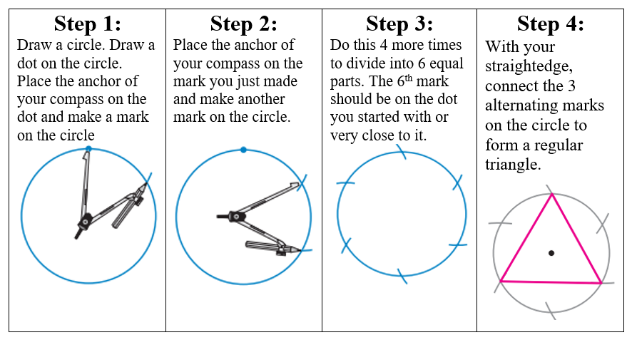
Example 1: Triangle Inscribed in a Circle

Construct a Triangle Inscribed in a Circle.

- Squares are also regular polygons, because all their angles are the same 90⁰ and all their sides are the same length.

Example 2: Square Inscribed in a Circle
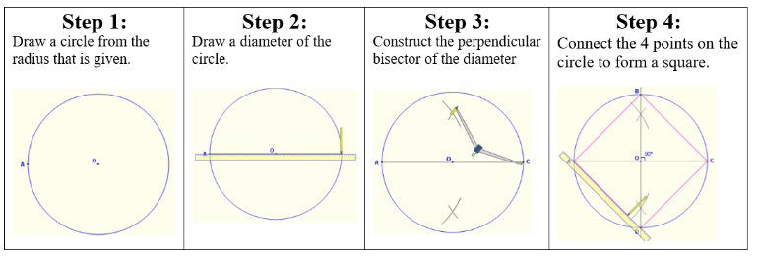

Construct a Square Inscribed in a Circle.

- A regular hexagon is a 6 sided polygon whose angles are all the same measure and sides are all the same length. The hexagon is inscribed in the circle because each vertex of the hexagon is on the circle.

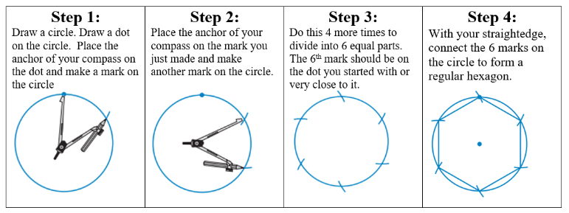
Example 3: Hexagon Inscribed in a Circle

Construct a Hexagon Inscribed in a Circle.

Constructions of Tangents, Circumscribed and Inscribed Circles
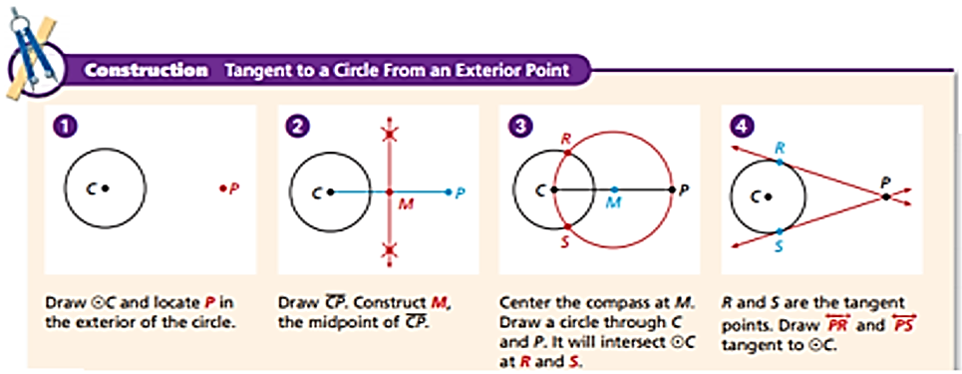

Example 1
Construct a Tangent to a Circle for an Exterior Point

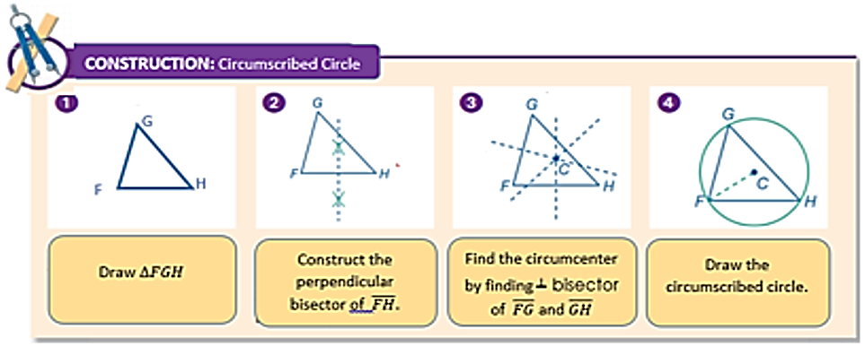

Example 2
Construct a Circumscribed Circle of a triangle.

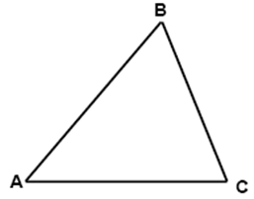

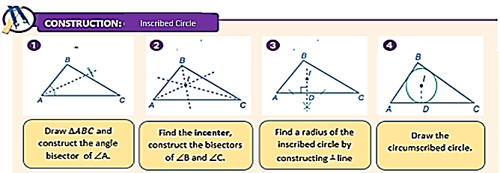

Example 4
Construct the inscribed circle of a triangle.

